Consultant profile: Robert Czyżewski
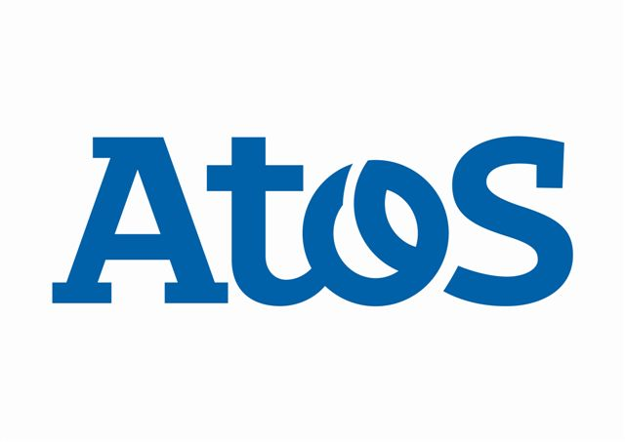

Summary of Qualifications
Robert Czyżewski is a consultant in FI, RE modules. He has many years of experience in financial departaments on positions related with industrial and bank controlling and as SAP FI key user.
The consultant has experience in implementation and integration SAP products in different market sectors, he knows typical SAP problems for the projects of “roll-out” type.
He has an experience in preparing the proposals and presentations of SAP solutions for customers, presales and sales support.
The consultant has good communication skills and ability to work in team.
Projects and Application Experience
2011 | Customer / Project name: Hella Polska Sp. z o.o.  Function: SAP consultant FI, FI-AA  Scope of responsibility: Polish Legal Requirements in FI, FI-AA configuration.
2010 | Customer / Project name: Coca- cola Polska  Function: SAP consultant FI, FI-AA  Scope of responsibility: Polish Legal Requirements in FI, FI-AA configuration.
2010 | Customer / Project name: Polski Komitet Normalizacyjny  Function: SAP consultant FI  Scope of responsibility: Support activities
2010 | Customer / Project name: MAPAL Narzędzia Precyzyjne  Function: SAP consultant FI  Scope of responsibility: Support activities
2009 | Customer / Project name: Urząd Miasta Warszawy  Function: SAP consultant FI-CA  Scope of responsibility: Support activities
11/09 | Customer / Project name: The Jagiellonian University of Krakow  Function: SAP leading consultant FI-CA Module  Scope of responsibilities: business blueprint preparation, system customizing
08/09 - today | Customer / Project name: The Jagiellonian University of Krakow  Function: SAP FI treasury service consultant
05/07 - today | Customer / Project name: Warsaw University of Technology  Function: SAP leading consultant FI-CA Module, SAP leading consultant RE Module, SAP consultant FI Module, SAP consultant AM Module  Scope of responsibilities: business blueprint preparation, system customizing
08/09 - today | Customer / Project name: SM Mlekpol  Function: SAP consultant FI Module  Scope of responsibilities: business blueprint preparation, data migration
Education
2001 | 5 steps Study for Financial Controllers - postgraduate education
1993-98 | Lodz University of Technology  Specialization: company finance managenment
Internal SAP Trainings:
- RE module training – 4 days,
- FI module training – 5 days,
- FI module training – 4 days, customization
- FI workshop- (3 days), customization,
- CO module training – 4 days.
External SAP Trainings:
- IHE 203 - (5 days) Student Lifecycle Management Student Accounting
- IUT 240 - (5 days) FI-CA SAP for Utilities
Languages
Polish  English  Język rosyjski | Mother tongue  fluent  basic
Additional knowledge
Microsoft Office: Excel, Access oraz Business Object.
SQL., Visual Basic for Excel
Hyperion oraz Essbasse Add-in Exel.
Unisoft , Symfonia oraz Exact programms.
Driving licence (since 1992 roku).
Good communication skills

