NON 2
entity non2 is
port ( e : in bit; s : out bit );
end non2;

architecture logic of non2 is
begin
s <= '1' when e = '0' else '0';
end logic;

*************
OU 3
entity ou3 is
port( e : in bit_vector (0 to 1); s : out bit );
end ou3;

architecture abstract of ou3 is
begin
process (e)
begin
case e is
when "00" => s<='0';
when others => s<='1';
end case;
end process;
end abstract;

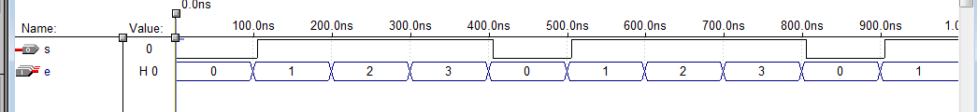

*************
MUX 2bv
entity mux2bv is
port(e0, e1, sel : in bit; s : out bit);
end mux2bv ;

architecture behav of mux2bv is
begin
process (e0, e1, sel)
begin
if sel = '0' then s <= e0;
else s <= e1;
end if;
end process;
end behav;

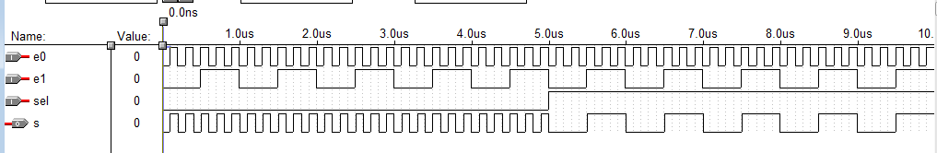

*************
D latch init
entity dlatchinit1 is
port(D, clock, init : in bit; Q : out bit);
end dlatchinit1 ;

architecture behav of dlatchinit1 is
begin
process (clock, D, init)
begin
if (init='1') then Q <= '1';
end if;
if (clock='1') then Q <= D;
end if;
end process;
end behav;

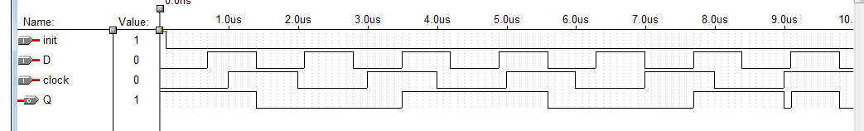

*************

D edge
entity dedge1 is
port(D, clock : in bit; Q : out bit);
end dedge1 ;

architecture primitive of dedge1 is
begin
process
begin
wait until clock = '1';
Q <= D;
end process;
end primitive;

