WHY PERFECT GRADES DON’T MATTER
Ted –ED animation

I Vocabulary
SAT: Reasoning test, national, to integrate universities
GPA: Grade Point Average, way of measuring academic achievement

Match the words to their definitions or synonyms

- Achievement
- Overwhelming
- Self-worth
- To track
- To attend
- On a daily basis
- College
- Valedictorian
- Peers
- Trailblazers
- Smart
- To correlate
- To take a toll
- Assessment
- Vocational school
- Unavoidable

- To have an adverse effect
- intelligent
- Every day
- To monitor
- Accomplishment
- University
- Inescapable
- Equal
- Very great, huge
- Pioneer
- Evaluation
- To correspond
- School preparing more to professional world
- Best student in a group
- Self-esteem
- To be present

II Comprehension
- When was the grading system created in the United states of America?
_______________________________________________________________________________
- A 2002 study revealed __% of students based their self-worth on their grades.

- 45&

- 80%

- 64%

- 55%

- Name 3 negative consequences of the use of grades, according to the document.
_____________________________________________________________________________________________________________________________________________________________________________________________________________________________________________
- A national survey of 24,000 students showed __% have cheated on a test.

- 40%
- 80%
- 46%
- 64%

- Researchers found high school students with lower grades and higher test scores performed worse in college. Why?
_____________________________________________________________________________________________________________________________________________________________________________________________________________________________________________
- What could contribute to Finland being ranked higher than the U.S. in academic achievement?
_____________________________________________________________________________________________________________________________________________________________________________________________________________________________________________

III Discussion
Do you think a student that strives to get A’s will retain the material beyond the test?

Why do you think valedictorians were not categorized as “visionaries or trailblazers” in the real world?

What do you think of the grading system for the ‘Anglais renforcé’ module?

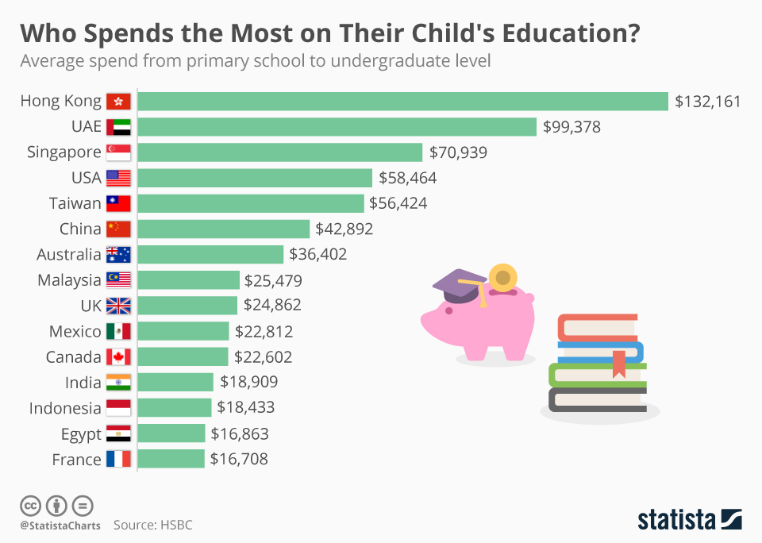

The Programme for International Student Assessment (PISA) is a worldwide study by the Organisation for Economic Co-operation and Development (OECD) in member and non-member nations intended to evaluate educational systems by measuring 15-year-old school pupils' scholastic performance on mathematics, science, and reading.

It was first performed in 2000 and then repeated every three years. Its aim is to provide comparable data with a view to enabling countries to improve their education policies and outcomes. It measures problem solving and cognition.

