DJ    18 year old required  P/T  Have a Driver’s licence  (Sat&Sun Fm 5-8 a.m.)  Wage : 7$ p/h  Must love music and have a good clear voice  Please telephone 020 3456 6651 |  | Dog Walker  Min 15y.o required  M-F 6x/day  Wage : $100/wk    Must Like dogs and like exercise  Please call 030 5678 8879

SECRETARY    18y.o and over  20 hours a week (Everyday except Wed)  Exp/pref  Wage : 15$ p/h  Must know computers (excel, pwpt and word)  be able to type 60 words a minute  have good phone skills  Apply ASAP |  | DELIVERY MAN    18-year-old required  M-F  am/pm  20h p/wk  Wage : 8$ p/h + tips  No exp req, avail immed  Have your own car/motorbike  Like to meet people  Please phone 020 6689 0973

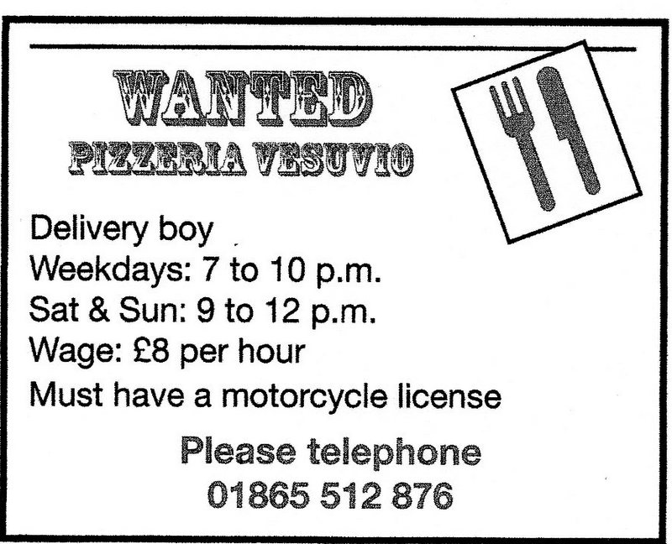
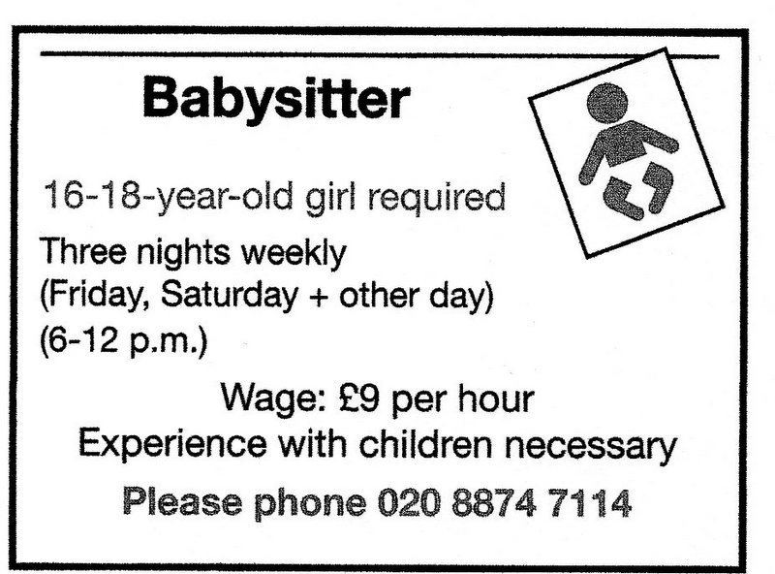

No exp req: no experience required  Exp pref: experience preferred  FT: Full-time work  PT: Part-time work | FT/PT: Full-time work or part-time work  am/pm: Day or night work  avail immed: available immediately  Apply ASAP: apply as soon as possible
VOCABULARY TO HELP YOU

