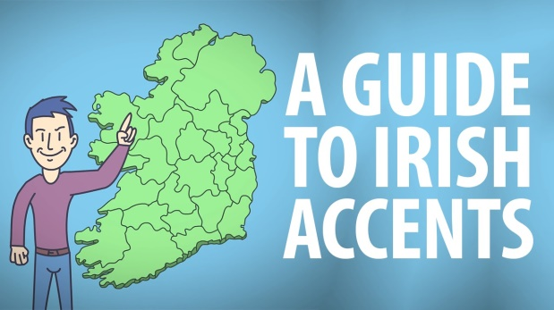
In which county/counties or region(s):
Irish Accents and Slang
.Vocabulary
- Get something straight
- Leprechauns on acid
- Set the record straight
- A relatively small city
- Forlorn
- For the craic
- Fair play to ya
- Gowl
- Acting the maggot
- Langers
- It’s totes* generalisation like

Have you heard any of the phrases above? Do you know what they mean?

Match them to an explanation below:
- Very drunk
- Clear up a misunderstanding (x2)
- An idiot
- Small mythical creatures on hallucinogenic drugs
- A city which is small when you compare it with most other cities
- Behaving in a stupid or playful manner
- Just for fun
- Well done! You did something very good.
- It’s not completely true, it just gives you an idea of how things are generally
- Seeming lonely and unhappy
*totes = totally
- do people speak with a nasal accent
- is ‘s’ pronounced ‘sh’
- are there two distinctly different accents
- do people pronounce ‘th’ like ‘d’
- was the accent heavily influenced by the British occupation
- do people have a melodic accent
- do people habitually say ‘boy’
- was influenced by the Scottish plantations
- are the vowel sounds elongated
- do people not pronounce ‘t’ when it’s the final letter in a word
- does ‘aye’ mean ‘yes’
- do people speak in a much higher pitch

Can you pronounce these words according to the accents in the video?
‘west’ ‘forget it’ ‘this, that, these and those’ ‘like totally the opposite’ ‘fair play to ya boy’ ‘it’s fast and it’s furious’ ‘you might get called a gowl’ ‘aye’ ‘now’ ‘I tell you it’s very different’ ‘forever’ ‘and it’s totes generalisation like’
‘but sure it is what it is boy’

