Look at the examples of Australian slang. Which expressions do you know already? Can you guess the others from the context?

- The man started getting a bit agro when he had had too much to drink.
- Our neighbours complained that their ankle-biters couldn’t sleep because of the noise.

- I’m going to watch the game tomorrow arvo.
- We have so much business at the moment, I’m as busy as a one-legged man in an arse kicking contest.

- I love the smell of snags on a barbie.
- A bloke came up to me and asked for directions.
- If you are going to the bottlo could you get us a slab of XXXX?
- My house is just down the road.
- I can’t believe you didn’t know the answer, you drongo.
- I saw a great footy match last night
- It was a terrible party – there was no grog and the grub/tucker was disgusting!
- If you can’t hack what he says, don’t talk to him!
- You’ve put in some hard yakka – Take a break.
- After so long not seeing my mates it was great to have a have a chinwag
- I’ll meet you in the boozer after work and we’ll sink a coldie or two.
- We each kicked in 20 bucks to help with the expenses.
- I think I’ll knock off work early on Friday.
- My brother likes KFC but I prefer Macca’s.
- How can you forget where you parked your car? What a mug!
- The employee went outside to have a smoko.
- After such a poor meal, the customer spat the dummy when he was overcharged.
- He’s such a tightarse – he’ll never offer to pay for anything.

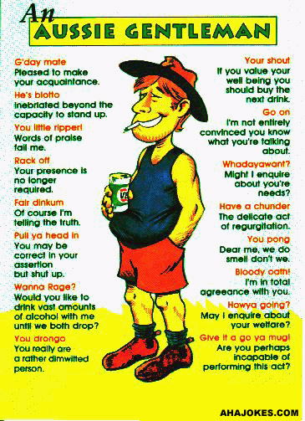 | 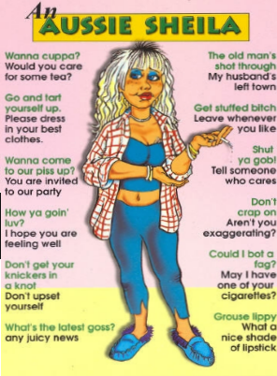

Read the text and translate it into “ordinary” English

Went to Macca’s yesterday arvo with some mates after the footy. I’d been as busy as a one-legged man in an arse kicking contest all week so it was good to have a chinwag with the boys. After that we went to the boozer and sank a few coldies. I went out for a smoko and started talking to a bloke, but he got a bit agro when I told him his team had played like a bunch of drongos. Not my fault if he can’t hack the truth! What a mug!
When we finished, we walked down the road to the nearest bottlo to get some more grog. Picked up a slab and went back to Stevo’s house. Once there, we started getting a bit hungry for some tucker so we fired up the barbie and threw a few snags on. We all kicked in a few bucks for the grub, except for Davo, who’s a bit of a tightarse! Stevo spat the dummy about that but he had to keep the noise down though, ‘cos of the ankle-biters! Anyway, I had to knock off fairly soon after ‘cos I had a day of hard yakka ahead of me.

