The Guardian - Back to home
Support The Guardian
Contribute
Subscribe
Search jobs
Sign in
Search
- News
- Opinion
- Sport
- Culture
- Lifestyle
- The Guardian view
- Columnists
- Cartoons
- Opinion videos
- Letters
Opinion
Social housing

How 'placemaking' is tearing apart social housing communities
Nye Jones
It’s gentrification by any other name, helping councils to force out tenants and decimate public housing
Thu 27 Dec 2018 12.40 GMT Last modified on Fri 28 Dec 2018 23.49 GMT

•
•
•
•

Shares
1,684

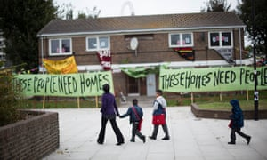
‘They just want to make more money.’ Four years after the protest by Focus E15 pictured here, more than 400 homes lie empty in the Carpenters estate. Photograph: Jess Hurd/reportdigital.co.uk
Joyce (not her real name) was in east London long before the Cereal Killer cafe, moving from East Ham to the Carpenters estate in Newham months before her son was born in 1972. She doesn’t describe a life of luxury: “We had young children, we had three bedrooms, [but] it was warm.” Nor was the community on the estate devoid of problems, but she made friends among her neighbours and was able to put down roots with the kind of security that is becoming increasingly rare.
She says her flat was in “perfect condition” apart from some ceiling damp, the result of a forgetful neighbour with a quick-running bath. So when she received a letter from Newham council in 2010 advising that the whole estate was going to be decanted for “refurbishment”, it came as a surprise.
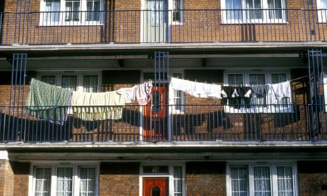

Social housing is a vanishing option for families who cannot afford to buy
Read more
Her fears were quelled when the council confirmed that once the refurbishment was over, residents who wanted to return would be more than welcome to do so (subject to availability). But seven years on, Joyce has not returned, and more than 400 properties on the estate sit empty. With the glistening Olympic stadium looming over it, the fate of the Carpenters estate represents an all-too-familiar story for social housing tenants across the capital.
Joyce moved to a nearby housing association property in 2011, avoiding the anxiety of having to negotiate a whole new area. Yet when I ask if she would move back into the Carpenters estate, her “yes” is unequivocal. She recently returned to visit her old flat with a member of the Focus E15 housing campaign group, and declared with a big smile that “I felt like I came back home.”
Between 2012 and 2017, Newham council rehoused more than 3,000 homeless families outside of the borough. Meanwhile, some London councils are shipping households as far away as Newcastle. So why are so many homes sitting empty when demand is grossly outweighing supply? Joyce doesn’t mince her words: “I think it’s because of the area and the potential in the area and they just want to make more money.”
Newham argue that it consulted the residents repeatedly between 2004 and 2009 but “every option was too expensive to be feasible as the costs outweighed the value of the leaseholders’ properties and council-owned flats”. Instead it tried to sell the properties to University College London.
Current Time 0:00
/
Duration Time 0:00
Loaded: 0%
Progress: 0%
Mute
Facebook Twitter
Pinterest
London’s housing crisis: the story of the Focus E15 mums
Advertisement
UCL was interested but ultimately withdrew from the estate following protests from its staff and students, as well as local residents. Selling to a university doesn’t scream of greed like signing it all away to an offshore company. But it would have generated “cultural capital”, which is a key component of “placemaking”, a vital stepping stone in attracting much more affluent people to an area.
Writer and academic Anna Minton describes how “placemaking” involves creating “‘innovation clusters’ – ideally featuring a university, commercial space, shops, restaurants and perhaps an art gallery, all alongside luxury apartments”. The fizz of culture and luxury are a cocktail that few deep-pocketed developers can resist. But this commitment is almost always to the detriment of social housing tenants, who are shooed out of the way. When the radical Hungarian architect Ernő Goldfinger designed the well-known Balfron Tower in Poplar, nearby in east London, he did so with the tenants in mind. He put all the bedrooms on the eastern side of the building so residents could enjoy the sunrise, while balconies are on the west to take in the sunset.
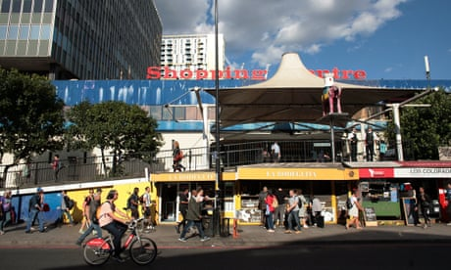

Save the Elephant: the fight to protect south London's 'anti-Westfield'
Read more
Yet those enjoying the personal touches of the tower are now doing so at sky-high London rents. Poplar HARCA, the housing association that manages the homes, started “decanting” residents from the property in 2008 saying that they would “possibly but not probably” have a “right of return” once the refurbishment was complete. Not a single one did. This decision to let all the flats at market rates coincided neatly with Poplar HARCA’s plans to regenerate the nearby Chrisp Street market to “create a thriving town centre”.
Elsewhere in London, Southwark’s council’s decision to demolish the Elephant and Castle shopping centre and surrounding homes to make way for a new university campus will likely result in a loss of social housing and significantly decreased space for local businesses. In all these cases, the social tenants were treated like cattle, herded elsewhere with minimal consultation about their wishes. What is left unsaid is the apparent attitude that they should just be happy to have a roof over their heads at all.
Yet Joyce talks about the Carpenters estate more like a lost sweetheart then a collection of bricks and mortar. “It’s like losing someone. You had made plans with that person, you were going to spend the rest of your life with that person. Then suddenly they change their mind. Obviously, it puts a dent in your everyday.”
The new Newham mayor, Rokhsana Fiaz, has changed tack from the previous council regime, promising that the fate of the estate will be decided by local residents and recommending that people whom the council displaced should be allowed back. Let’s hope this a genuine promise rather than empty words. “Placemaking” wrenches social housing communities away from their homes because they don’t fit in with the developer’s dream. It’s heart-breaking.
• Nye Jones is a freelance writer and housing campaigner. @nyejones92

