The Guardian - Back to home
Support The Guardian
Contribute Subscribe
Search jobs
Sign in
Search
- News
- Opinion
- Sport
- Culture
- Lifestyle
- World
- Europe
- US
- Americas
- Asia
- Australia
- Middle East
- Africa
- Inequality
- Cities
- Global development
Opinion
Emmanuel Macron

Macron’s crisis in France is a danger to all of Europe

Natalie Nougayrède
Extreme forces are rejoicing over the president’s predicament. Their ultimate goal is a political takeover of the continent
Tue 4 Dec 2018 19.00 GMT Last modified on Tue 4 Dec 2018 22.43 GMT

•
•
•
•

Shares
5,756

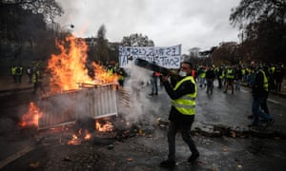
‘France suffers from deep domestic fault lines which one president alone could hardly heal in just 18 months.’ Photograph: Abdulmonam Eassa/AFP/Getty Images
For Europe’s sake, Emmanuel Macron needs help – not our scorn or hatred. A young, reformist French president who promised a “European renaissance” finds himself struggling at the helm of a country that is fast becoming “the sick man of Europe” again. It was a telling moment last weekend when rioters disfigured the face of a statue of Marianne, the republic’s symbol, at the Arc de Triomphe in Paris. Just three weeks earlier, world leaders had gathered there with Macron for the centenary of the Armistice. If the “sad passions” that Macron has warned of many times take hold in France, an entire continent will be affected – not just one man’s political career.
Extreme forces across Europe are busily rejoicing over Macron’s gilets jaunes predicament. From Britain’s hardline Brexiters (both left and right) to Italy’s far-right strongman Matteo Salvini, not to mention Putin’s propaganda outlets, the relish is unmistakable. Upheaval and chaos in liberal democracies is what they thrive on. The prize the extremists seek is a political takeover of Europe in next May’s European parliament elections. Events in France are ominous, and their significance extends far beyond one country’s borders.
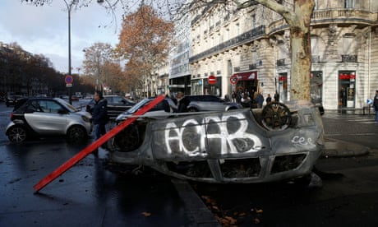

The aftermath of the gilets jaunes riots in Paris – in pictures
Not long ago, Macron proudly branded himself as the arch enemy of Salvini and Hungary’s Viktor Orbán, two leaders whose trademark policies target migrants, political opponents and the rule of law. Macron is weakened, on the defensive, and ever more isolated.
Scenes in France these past two weeks may seem, to some, like a revival of the May 1968 uprising, but a more pertinent parallel may be 6 February 1934. That day, gangs of far-right nationalists marched on the French capital and clashed with the police in violence that left 15 dead. The events of the day served as a founding myth for that generation of France’s far right.
Macron has certainly made mistakes. Most of the protesters have genuine, if chaotically expressed, grievances. They consider themselves the “invisible” people treated with contempt by Parisian elites, and now they’ve made themselves very visible with their fluorescent vests. Public opinion is behind them.
One of their most eloquent members is Ingrid Levavasseur, a young nurse and single mother of two from Normandy. Last week she spoke movingly on television of her struggle to make ends meet, and of her sense of deep injustice: “Some people complain that we block roads, but they don’t complain when they’re stuck in traffic jams on their way to ski resorts, do they?” she asked softly.
0:50
Police and protesters clash in Paris – video
Advertisement
But France’s crisis has more sinister undercurrents, embodied by another gilets jaunes spokesperson, Christophe Chalençon. A blacksmith from the southern Vaucluse region, Chalençon is openly anti-Muslim and has called for a military-led government to be installed – “because a true commander, a general, a strong hand is what we need”. Far-right outfits such as Action Française are meanwhile trying to make a comeback.
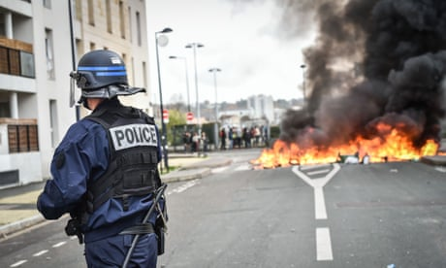

Gilets jaunes protests in France to continue despite fuel tax U-turn
Read more
Today’s announcement that tax rises would be suspended is probably too little, too late. French anxieties are threefold. There is the fear of losing power and prestige; the fear of the economic impact of globalisation, and the fear of losing a “national identity”. The country also suffers from deep domestic fault lines which one president alone could hardly heal in just eighteen months.
Entire social groups feel pitted against one another: young versus old, unemployed versus employed, rural versus urban, unqualified versus educated. Such divisions exist in many countries, but in France they take on an existential dimension because of the ideal of egalitarianism historically associated with the republic. Many French people feel reality doesn’t reflect what they are entitled to have.
When Macron ran for office in 2017, he promised a “revolution” (it was even the title of his campaign book) to address a widespread need for domestic renewal and a rebooting of French prestige, not least on the European stage.
Now the president looks paralysed at home, and the last rites could soon be read over his European plans. Just as a weakened Merkel didn’t do much to help Macron in relaunching the European project, a weakened Macron will now provide new fodder for extremists and populists across the continent. The Le Pens, Orbáns and Salvinis are waiting in the wings. If we don’t find solutions, the EU election in France risks becoming a referendum against Macron.
So the gloss has come off the French president as a champion for liberals and pro-Europeans. But to see that as good news for Europe and democracy at large is mind-bogglingly dangerous. It’s like wishing for a train crash so that some carriages can be replaced. Social pains in France are real, and must be addressed. But the forces which stand to gain from collective wreckage and street violence are those that will push us into an abyss. Look at the death threats made to the gilets jaunes who said they were ready to negotiate with the government.
A few years ago an exhausted, tense Italy had its “vaffanculo days” of protests (the message being: “fuck you” to the establishment) from which the populist Five Star movement grew its strength. What’s happened since? This year, Italy has fallen into the grip of the far right. France’s current “vaffanculo days” will lead to a similar scenario if sober-minded people don’t somehow help Macron rebuild a minimum of trust. There can be no European democratic project or social justice without a European democratic France. Marianne’s face must be restored.
•Natalie Nougayrède is a Guardian columnist

