The Guardian - Back to home
Support The Guardian
Contribute
Subscribe
Search jobs
Sign in
Search
- News
- Opinion
- Sport
- Culture
- Lifestyle
- World
- Europe
- US
- Americas
- Asia
- Australia
- Middle East
- Africa
- Inequality
- Cities
- Global development

The woman breaking Bolivia's culture of silence on rape
Women's rights and gender equality
Global development
Raped at the age of 15, Brisa De Angulo has devoted her life to the pursuit of justice for herself and fellow survivors of sexual abuse. In the process, she has survived several attempts on her life and influenced crucial changes to the law
Supported by
About this content
Dan Collyns in Cochabamba
@yachay_dc
Fri 28 Dec 2018 07.00 GMT Last modified on Fri 28 Dec 2018 11.21 GMT

•
•
•
•

Shares
281

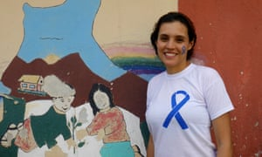
Brisa De Angulo stands by the painting she designed when she founded her centre outside Cochabamba as a teenager. Photograph: Dan Collyns
Brisa De Angulo was 15 when the carefree, happy childhood she lived in her Bolivian village was shattered.
She was raped by a member of her extended family who was lodging at the family home, on the outskirts of the city of Cochabamba. Over eight months she was raped repeatedly.
“I developed bulimia and then I developed anorexia and I tried to commit suicide twice,” says the 32-year-old. “My parents knew something was wrong but they could never imagine I was being raped in my own home by a family member.”
When she was 16 she tried to press rape charges. The process proved so traumatic she decided to dedicate her life to ensuring no other girl would go through the same experience.
Advertisement
In 2004, when she was 17, De Angulo opened Bolivia’s first – and still only – comprehensive support centre for child survivors of sexual violence, which led to the creation of the charity A Breeze of Hope. Since then, the centre has had unprecedented success in bringing perpetrators to court.
Bolivia has one of the highest rates of violence against women in Latin America. Six out of 10 women in the country will suffer physical and/or sexual violence at the hands of an intimate partner at some point in their life, according to data analysed in 2018 by the Pan American Health Organization.
“I had no idea what I was getting myself into,” says De Angulo, of the time when she reported her attacker. She says she received “intimidation from the judicial system, from the community, from what I call my ex-family and from the government, who tried to silence me”.
She continues: “My house was set on fire twice, I was almost run over by a car several times, I was threatened with being killed several times, my house was stoned.”
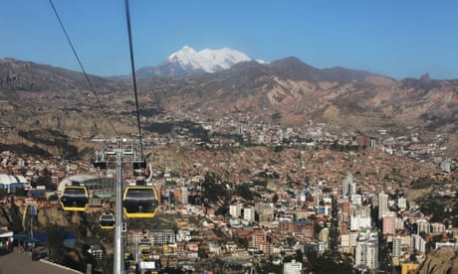

Bolivia women's rights groups hope revised law is step toward legal abortion
Read more
When her case eventually reached a court about a year after she had reported the crime, it was heard at the livestock and agriculture court – an odd move, apparently designed to insult her.
After three appeals, her case was finally referred to Bolivia’s constitutional court. A new trial date was set, but her attacker skipped bail and fled the country.
De Angulo has since taken her rape case to the Inter-American Commission on Human Rights. With the support of the NGO Equality Now, she is requesting the repeal of a provision in the law known as estupro, which permits lower sentences for raping 14- to 18-year-olds than for attacks on younger children.
Over the past 14 years, De Angulo estimates that A Breeze of Hope’s legal team have prosecuted up to 500 abuse cases. Remarkably, the charity boosted its own 96% conviction rate, which hit 100% last year – a stark improvement on the Bolivian judiciary’s dismal 2% rate of conviction for sexual assaults on children. Around 65% of the workers in the charity, including the legal team, are sexual abuse survivors and they are specialised in getting the standards of proof required for abuse cases.

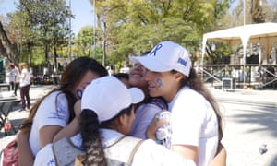

Facebook Twitter
Pinterest
Brisa De Angulo embraces young women who are beneficiaries of her charity in Cochabamba, Bolivia. Photograph: Dan Collyns
The charity’s unprecedented success led, in 2016, to De Angulo being named a UN Together for Girls hero for tackling violence.
As well as securing high conviction rates, the centre places equal importance on addressing the psychological and physical scars of violence. De Angulo, who has a doctorate in neuropsychology, has pioneered studies on how the brain processes childhood trauma. The first step in the process, she says, is dealing with the victims’ sympathetic nervous system – their “fight or flight” response to an experience.
Breathing exercises and yoga come first, she explains. Once the physical symptoms of the trauma are more under control, clinicians move on to cognitive behavioural therapy, including play therapy for the youngest children who cannot explain in words the abuse they experienced.
Tamar Molina, 23, is one of the charity’s 1,700 beneficiaries, and like many others has become an activist for children’s rights.
“When I was 12 my father started sexually abusing me. When I turned 17 I broke my silence to my mother,” she says.
After being turned away by various state legal agencies, she was helped by A Breeze of Hope’s legal team to prosecute her father. He was sentenced to 15 years in prison and the charity has become her home after she was ostracised from her family as a result.
“I felt very guilty because I was splitting up the family. But we’re not the guilty ones, we’ve haven’t done anything wrong. The guilty one is the aggressor,” she says.

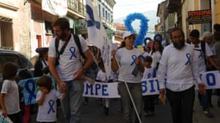

Facebook Twitter
Pinterest
Supporters take part in Bolivia’s annual march in solidarity with victims of sexual violence in Cochabamba. Photograph: Dan Collyns
Changing the culture of shame and victim blame that surrounds sexual violence is vital, says De Angulo. Because of her tenacity, the government has declared a national day of solidarity with the victims of sexual violence every 9 August.
Her work has also prompted legal reform in Bolivia, a toughening of the criminal code and strengthening of child protection mechanisms in the legal system. In 2013, De Angulo successfully forced the repeal of a marital rape exemption from the penal code.
“I couldn’t ask any other girls to break the silence if I wasn’t willing to open the path for them,” she says. “There’s nothing in my life that I could do right now other than what I am doing.”
Topics

