The Guardian - Back to home
Support The Guardian
Contribute
Subscribe
Search jobs
Sign in
Search
- News
- Opinion
- Sport
- Culture
- Lifestyle
Retail industry

Boxing Day sales draw fewer UK shoppers
Number of visitors to shopping centres, high streets and retail parks drops 3.1% compared with last year
‘I like to get my hands on things’: Boxing Day shoppers hit the sales
Sarah Butler
@whatbutlersaw
Wed 26 Dec 2018 15.36 GMT First published on Wed 26 Dec 2018 13.53 GMT

•
•
•
•

Shares
79

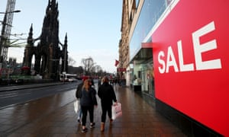
Bricks-and-mortar retailers saw about 4% fewer visitors than the previous year up to December 26. Photograph: Jane Barlow/PA
The number of shoppers visiting retailers on Boxing Day has fallen for the third year in a row as worries about the economy and the rise of internet shopping take their toll on high streets.
The average number of visitors to shopping centres, high streets and retail parks had slid 3.1%year-on-year by 4pm on Wednesday, according to data from analysts at Springboard. Sales were up slightly in London and Scotland and strongly in Wales, but down across the rest of the UK.
Diane Wehrle, insights director at at Springboard, said: “Boxing Day has become less important as a trading day. You don’t get that massive surge, particularly as we’ve had virtually continuous discounting since Black Friday [at the end of November].”


'I like to get my hands on things': Boxing Day shoppers hit the sales
Read more
She said the disappointing figures meant that retailers had seen about 4% fewer visitors to physical stores for December so far, and that this would be only partly offset by an increase in sales online.
“Online sales are still growing, but growth is less this year than last year,” she said. She added that the level of discounts also appeared to have ramped up as consumers were so used to being lured with promotions that price cuts of 20% or 30% had little effect.
On Wednesday, that problem was all too evident: Topshop had increased its discounts up to 70% off from 60% last week, while jeweller H Samuel and shoe shop Clarks had joined House of Fraser, River Island and New Look in offering 60% off.
Quick guide

Why are high street retailers in trouble?
The average discount being offered on Boxing Day by those retailers with an online presence was 43%, according to Lovethesales.com, six percentage points higher than last year. Nearly 54% of products sold online are discounted, compared with 51.3% last year, while clothing was carrying the highest level of discount since Lovethesales began monitoring in 2013.
Retailers have been struggling to clear stock as economic and political uncertainty linked to Brexit has put a dampener on consumer confidence just at a time when high street retailers are already under pressure from a switch to selling online.
However, Intu, which runs some of the UK’s biggest shopping centres, including Trafford Centre in Manchester and Lakeside in Essex, said thousands of shoppers around the country had queued up from the early hours of the morning in order to secure bargains. About 20,000 people had visited the Trafford Centre by 10am, a similar number to last year.
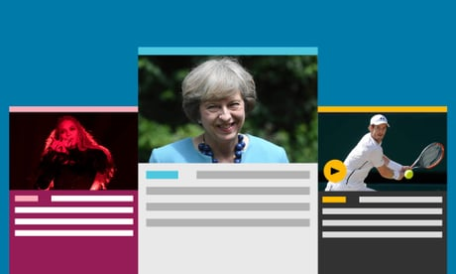

Guardian Today: the headlines, the analysis, the debate - sent direct to you
Read more
Advertisement
Gordon McKinnon, group operations director at Intu, said there was no doubt that shoppers had left their Christmas shopping later than ever, partly because of the timing of payday.
He said Black Friday shopping event in November had not been as strong as last year, but then trading had picked up throughout December, ending in a last-minute surge.
“The last three days [before Christmas Day] were exceptionally busy,” McKinnon said. “Online is bigger than ever before, but there comes a point when you just have to get to the shops.”
London’s main shopping destination, Oxford Street, had welcomed 16% more shoppers by 3pm on Boxing Day than appeared last year. The New West End Company, which represents retail businesses in the central London shopping district, said it expected shoppers to spend £50m on Boxing Day.
Jace Tyrrell, the chief executive of the New West End Company, said he expected sales for the eight-week festive shopping season as a whole to be slightly down on last year at £2.5bn. But he said central London was still likely to perform better than the country as a whole because of tourists, who spend as much as five times more than locals. The number of visitors to the West End’s shopping streets from China alone is up 40% year on year.
“It’s certainly been a tough November and December, but things have picked up in the last two weeks. It’s challenging, but the high-end luxury end of the market, such as Bond Street, is holding its own. It’s the high street and fashion that have been squeezed.”
Michael Ward, managing director of Harrods, said he expected to see the same number of shoppers as last year at the Knightsbridge department store as it welcomed an “international clientele” from China, the Middle East and elsewhere.
Sign up to the daily Business Today email or follow Guardian Business on Twitter at @BusinessDesk
He said Harrods’ sales were likely to be down compared with last year because of refurbishment work. Despite troubles at House of Fraser and Debenhams, Ward said department stores were not a dying breed. “We are not just putting out racks of clothing; we are creating experiences for our customers,” he said. “If you have never differentiated your product and had the same offering on the high street for the past 20 years, of course you are going to suffer. We haven’t done that. We’ve been very agile.”
He claimed that Harrods was the second biggest payer of business rates in the country and said the government needed to do more to balance the burden of taxes and legislation on physical retailers and online sellers. “Creating a level playing field on the high street is hugely urgent,” he said.

