Advertisement
The Guardian - Back to home
Support The Guardian
Contribute
Subscribe
Search jobs
Sign in
Search
- News
- Opinion
- Sport
- Culture
- Lifestyle
- Education
- Schools
- Teachers
- Universities
- Students
South Korea

'Blatantly sexist': backlash against South Korea's sex education
Students are taught from a young age that women must look pretty and men must earn a lot of money
Benjamin Haas in Seoul
@haasbenjamin
Fri 28 Dec 2018 08.28 GMT Last modified on Fri 28 Dec 2018 08.39 GMT

•
•
•
•

Shares
3,250

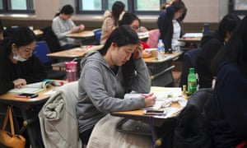
Students sit exams at a high school in Seoul. Government guidelines say that if men spend a lot of money on dates it is ‘natural’ for them to want to be compensated. Photograph: Jung Yeon-Je/AFP/Getty Images
Finding the perfect life partner can be difficult, but South Korean students are taught from an early age the ideal method for attracting a spouse is really quite simple.
“Women have to work on their appearance and men have to work on improving their financial capabilities,” say the government guidelines for high school pupils.
When dating begins, the guidelines carry a warning: “For men who spend a lot of money on dates, it is natural he would want to be compensated for the money spent. In such cases, unwanted date rape can occur”.
The guidelines, developed by the education ministry at a cost of 600m won (£420,000), instantly sparked controversy when they were first released in 2015. The texts were criticised for reinforcing gender stereotypes, ignoring reality and being “blatantly sexist”.
Males can have sexual intercourse extensively with women they are only sexually attracted to
South Korea sex education guidelines
Despite the backlash the ministry initially stood its ground, simply removing the material from its website and out of public view. While the education ministry declined provide a copy, the Guardian was able to review the guidelines in their entirety.
Following continuing outcry, the government pledged to review the guidelines in March, however, the current guidelines are still in use and there is no timeline for updated material, according to Cho Myung-yeon, head of the ministry’s student health policy department.
Cho said changes to the material can’t happen overnight.
“Revamping the guidelines isn’t simple because it requires an entire process like researchers exchanging opinions,” he said. “It’s difficult to say whether the ones we came up with in 2015 were problematic.”
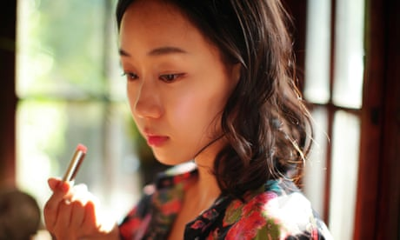

'Escape the corset': South Korean women rebel against strict beauty standards
Read more
In the meantime, amid a growing feminist movement in South Korea, teachers and parents are turning to after-school discussions groups and private lessons to help students unlearn the material they are taught in school.
“The guidelines are forcing students to be female or male according to the standards the government came up with,” said Kim Sung-ae, a high school teacher and vocal critic of sex education as practiced in South Korea.
“They set out the narrative of students’ lives: that they are born, meet a man or woman they love, they get married, have babies and raise kids. Assuming everyone should live this way doesn’t reflect reality and ignores people’s diverse lifestyles.”
Advertisement
Starting in elementary school, students are required to sit for 15 hours of sex education a year. In middle school they are taught they should never be alone with someone of the opposite sex. In high school, the guidelines explain: “Females sexually respond to one specific male, whereas males can have sexual intercourse extensively with women they are only sexually attracted to”.
As South Korea grapples with an epidemic of harassment in public – most often in the form of illegal filming – women are also told that if they are sexually harassed on public transportation they should “step on the perpetrator’s foot as if by mistake”.
In response, some parents have opted to send their children to private classes. One school in Seoul saw their enrolment more than double this year, with parents spending about 50,000 won (£35) for each two-hour session.
Teachers have also started to rebel, holding outside discussion groups that cover everything from sexual harassment to menstruation to LGBT issues. Yim Yi-rang, a high-school English teacher, has spoken with about 150 students since she started one such group about a year ago.
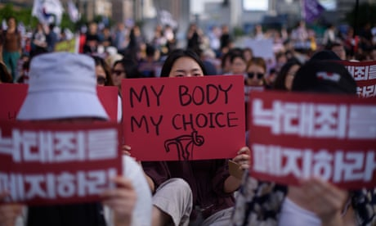

South Korea's nascent feminist movement turns to abortion ban
Read more
“Students are interested in gender issues,” she said. “But not only are these issues not discussed in the classroom, some teachers even make sexist remarks to students.”
Correcting sexist attitudes in education is a daunting task in a country where many believe “feminist” is a dirty word. Yim says she was shouted at by fellow teachers for hanging posters raising awareness about sexual harassment. Students in Yim’s discussion club rejected using the word feminist in the group’s name for fear the appearance in their academic file would harm future prospects and their male classmates would berate them. Instead it is known as the “human rights club”.
But teachers are not hopeful the revised guidelines will tackle the problems they see every day.
“The education ministry itself lacks sexual sensitivity,” Yim said. “I don’t have high expectations because the same people who came up with the current ones are working on the news ones.”

