The Guardian - Back to home
Support The Guardian
Contribute
Subscribe
Search jobs
Sign in
Search
- News
- Opinion
- Sport
- Culture
- Lifestyle
- UK
- UK politics
- Education
- Media
- Society
- Law
- Scotland
- Wales
- Northern Ireland
Homelessness

Tens of thousands of young people affected by homelessness, data shows
Figures obtained by Lib Dems from 234 councils show almost 45,000 people aged 18-24 have come forward in past year for help with homelessness
- Support our charity appeal by donating here
Anushka Asthana Political editor
Mon 25 Dec 2017 15.00 GMT Last modified on Mon 25 Dec 2017 22.00 GMT

•
•
•
•

This article is over 1 year old
Shares
1,093

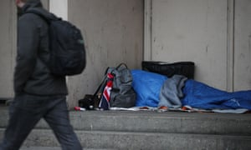
The Liberal Democrats said the figures exposed a ‘national scandal’. Photograph: Yui Mok/PA
Councils across England, Scotland and Wales have released statistics that show tens of thousands of young people have come forward to say they are either homeless or at risk of becoming homeless over the past year.
Figures from 234 councils obtained through a freedom of information request have lifted the lid on a hidden epidemic, with almost 45,000 18- to 24-year-olds approaching their local authority over the past year.
However, with more than 100 local authorities not providing information, the real statistic could well be above 70,000.
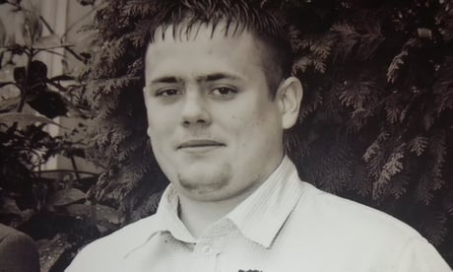

This man died sleeping on Birmingham streets. What happened to his life?
Read more
Vince Cable, the leader of the Liberal Democrats, which carried out the research, said the revelation exposed a “national scandal”.
“These figures reveal the hidden homelessness crisis affecting young people, with an estimated 70,000 18- to 24-year-olds across the country turning to councils for help,” he said.
“The situation is being made worse by the government’s heartless decision to strip young people of housing benefit.”
Charities have said that the government’s decision to keep housing benefit frozen has exacerbated the problem, with the gap growing between funds and rent levels.
But there are also fears about the move to block single 18- to 21-year-olds from receiving any help with housing costs, unless they can prove they are particularly vulnerable, within universal credit that is rolling out across the country.
Advertisement
Jean Templeton, the chief executive of St Basils, an organisation that works with young homeless people, said the benefit change had left many facing a “catch 22” situation.
“The underlying presumption that 18- to 21-year-olds are not entitled to support with housing costs places them in an impossible situation whereby they are unlikely to receive an offer of accommodation, as landlords who have several tenancy options presume their rent is at risk,” she said.
But without an offer, people cannot apply for housing support nor the necessary exemption if they are aged between 18 and 21, she said, warning that this placed more young people at risk of rough sleeping and unsafe housing options.
The figures show that many more young people are turning up at their local council to warn of a risk of homelessness than are actually being accepted as in need of urgent support. Of the 45,000 presenting as at risk of losing their home in the year up to September 2017, only 10,000 were classified as statutory homeless.

The Guardian view on rough sleeping: no room at the inn
Read more
The data shows the highest numbers were in Bradford (1,828), followed by Manchester (1,297), Cornwall (1,127), Nottingham (1,091) and then Telford and Wrekin (1,051).
Manchester city council said homelessness was a national problem “being stoked by welfare changes and the ongoing impact of austerity” and said young people were far from immune. It said the government had dismantled safety nets that used to exist, but insisted it was working hard to tackle the issue, including through prevention.
In Cornwall, a spokeswoman stressed that young people with partners and children did qualify for more support, but said the council worked hard to prevent homelessness among single people as well. One drive is to offer “mediation and whole family support” to help secure a place to live with loved ones, she said.
She said the council had put money in to help reduce rough sleeping.
A spokesman for the Local Government Association said: “It is a tragedy when anyone becomes homeless.” He said councils worked hard to prevent people losing their homes, or find new accommodation, and that a chronic shortage of affordable housing was making it very difficult to find emergency solutions.
Charities expressed deep concern about the plight of young people, with Paul Noblet of Centrepoint saying the most alarming thing about the figures was that they were likely to be a serious underestimate given that not all councils responded. Moreover, many young people would not know to turn to the council for help, he said.
“As a country, if we want to break the cycle of homelessness we need to be honest about the scale of the problem and decide if we are serious about solving it,” said Noblet.
Polly Neate, the chief executive of Shelter, said losing a home was a terrifying prospect.“At the very point when [young people] should be full of hope and looking forward to starting out in life, many are instead threatened with homelessness,” she said.
A government spokesman said: “Councils have a duty to help those most in need of temporary accommodation, and we continue to spend £24bn a year helping people across the UK with their housing costs.
“Government is providing over £1bn up to 2020 to reduce all forms of homelessness and we are investing in a Fair Chance Programme to support 18- to 25-year-olds with specific needs to help them find suitable accommodation and support their needs.”
He also pointed to the implementation of the Homelessness Reduction Act.

