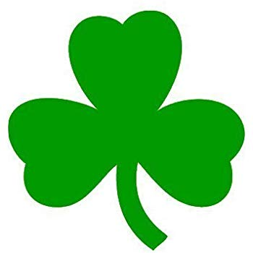
IRELAND

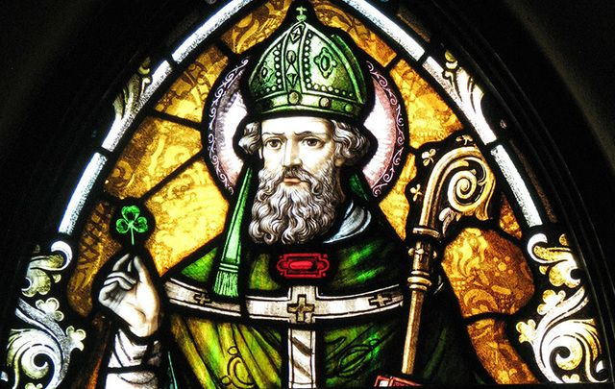

Saint Patrick was a missionary* who evangelised Ireland during the second half of the 5th century. He converted the people who practised a kind of Celtic polytheism. He sought to convert the warriors to Christianity, while they defended their pagan* past. On stained glasses* - as on the picture above - he is depicted* with a shamrock*.
He explained the doctrine of the Holy Trinity to pagans by showing people this plant.
- How did he manage?

17th March is believed to be his date of death and is celebrated as his Feast Day*.
- What nickname do we use for Patrick?

The shamrock as well as the harp symbolise Ireland. The harp was used as an icon on the coat of arms * of Ireland. The famous Brian Boru Harp is exhibited at Trinity College in Dublin, it is one of the oldest in the world.

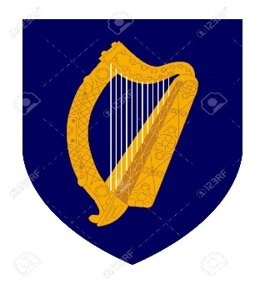
The Norman invasion in 1169 – 3) Remember who led this invasion and then became King of England? (We talked about him last year!!) – resulted in partial conquest of the island and marked the beginning of 800 years of English political and military involvement in Ireland.
From 1541 Ireland had been in Personal Union with England. It means that the Irish Parliament (composed of Protestants) had passed an act proclaiming King Henry VIII, King of Ireland as well as King of England.
4) Any particular knowledge about this king? Who did he marry and who were his two famous daughters? What happened between him and the Vatican?

Before 1541, many Protestants came from England but also from Scotland and settled in Ireland. The Personal Union marked the collapse of the Gaelic system and the beginning of Ireland’s history as part of the British Empire. The Protestants who were more powerful and well organised became landholders*. Although they constituted a minority they were in a position to dispossess the Catholic majority.

In 1801 the Act of Union was passed. It led to the unification of the Kingdom of Great Britain (England + Scotland + Wales) and the Kingdom of Ireland.
5) How did this Act impact the Union Jack? As for the origin of the flag name….. why Jack?
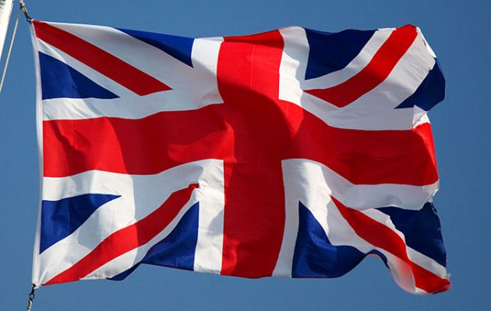
In the 19th century the Potato Blight (1845) destroyed the harvest. The Irish population, who was already poverty-stricken* started to undergo several years of starvation known as the Great Famine. In consequence, one million people died and another one million emigrated from Ireland. This situation reinforced hatred against England.

In 1873 the Home Rule movement was created in opposition to British Rule. The idea was to become autonomous within Great Britain (that is refuse rules coming from England). Many ‘Home Rules’ followed involving rewordings, changes in terms of agreement… However Home Rules, whatever their contents, were not welcomed by independence activists who refused any links with the UK.

In 1905, Sinn Fein was founded. It means ‘Ourselves’ in Irish. It is a political party that aims to assert the national sovereignty *and self-determination of the Irish people by governing themselves, rather than being part of a political union with Great Britain. This party is the political party of the people in favour of independence.

Sinn Fein is the largest political party and was historically associated with the IRA (Irish Republican Army), and has also been associated with the Provisional IRA (modern party).
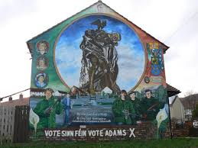

The IRA was a paramilitary movement in Ireland in the 20th century dedicated to Irish Republicanism, the belief that all of Ireland should be an independent Republic from British Rule and form their own government. Today it is known as the Provisional IRA and is proscribed as a terrorist group by the UK Government.

The Easter Rising took place in 1916. It was a rebellion against British Rule during World War 1 and led to 400 deaths. Although the rebellion was defeated, it was the first time that Catholics had led a rebellion and not Protestants. It represented a failure of the Home Rule and the first step towards the Republic of Ireland and the War of Independence.

The War of Independence lasted three years from 1919 to 1921. The Anglo/Irish treaty put an end to this war. This is how the Irish Free State came into existence. Ireland was to become a self-governing dominion of the British Empire, a status shared by Australia, Canada and the Union of South Africa.
The War of Independence was followed by the Irish Civil War, which opposed Irish Republicans and Irish Nationalists.
The Republicans are in favour of one independent Ireland and against the presence of British on the island.
The Nationalists are Catholic and defend their Gaelic culture. They are in favour of Eire.

This led to the Republic of Ireland Act in 1948. The island split into two, on one side The Republic of Ireland (also called Eire) and on the other Ulster or Northern Ireland, that remained part of Great Britain.

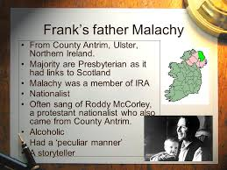
Poverty is everywhere but especially among catholic people.

This is the descriptionof the main character Malachy in the famaous book/fim:Angela’s Ashes to be read or seen to better understand the misery the people had to undergo not that long ago.

Ireland – Border in red, today you can go from one side to the other side completely freely. Between Dublin and Belfast it takes a little bit more than two hours. No customs officers*, no ID control.
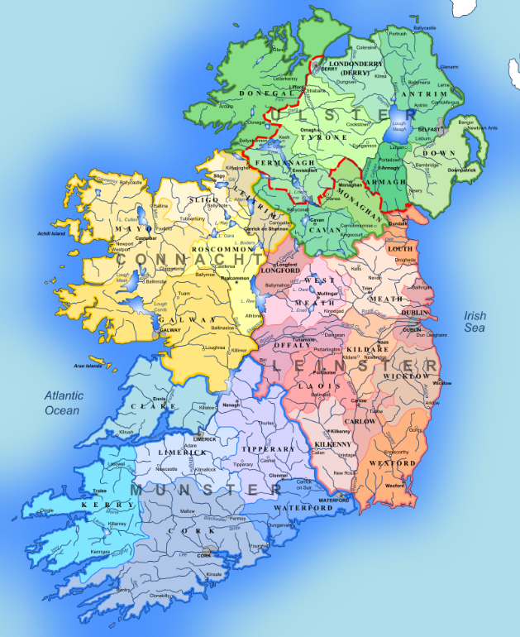

The Troubles is the name given to the period of conflict between the Nationalists and Republicans (the Catholics) against the Loyalists and the Unionists (the Protestants) and lasted approximately 30 years. The conflict started in the second half of the 1960’s.

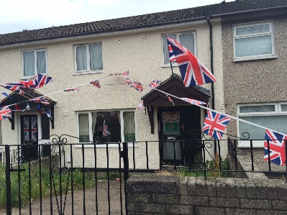
On the left hand-side you can see a Unionist’s house in Shankill Belfast, a unionist district. The inhabitants want to show their attachment to the British Kingdom so you can see many Union Jacks floating or sometimes you can even see flags with the Queen’s portrait.

Tourists can book a tour of Shankill if they are in Belfast or a tour of Londonderry or Derry and see the famous Murals depicting the history of the country. The Murals are considered as an artistic as well as a historical heritage and are part of the Irish landscape and landmarks. They are a ‘must see’ if you go to Ulster as much as the Giant Causeway or the Carrick-A-Rede Bridge… or even the Game of Thrones sceneries.

The conflict is sometimes described as a guerrilla war or terrorism as many civilians on the islands of Ireland and Britain were killed during bomb attacks and riots... Still today historians cannot agree on the way to categorise the Troubles. The conflict became so violent that there were some city districts in Ulster where Catholic could not go and vice versa. There was a real partition and walls were built separating neighbourhoods.
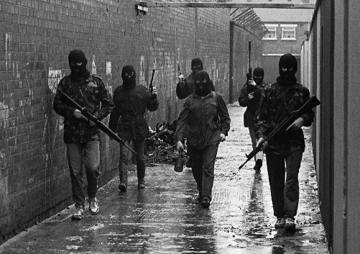
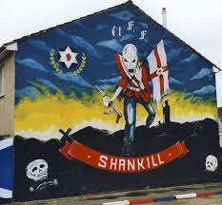
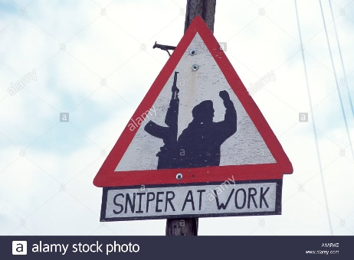
Snipers hid in buildings to take aim and shoot at their enemies. | Mural in Shankill by Unionists to show their strength and intimidate their enemy. | IRA Gun men in West Belfast during the Troubles.
The key issue wasn’t religious. In fact, it was centred on the constitutional status of Northern Ireland. The main participants in the Troubles were Republican paramilitaries such as the Provisional IRA against Ulster Volunteer Force and the British Army.
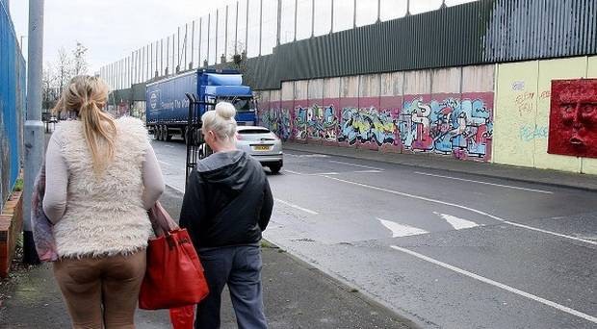
The Wall in Belfast separating the Unionists from the Nationalists.

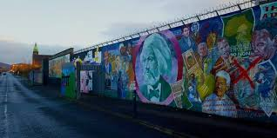
The drawings on the Murals don’t always represent Irish political issues, some like this one where we can see Karl Marx and it seems Nelson Mandela are there to symbolize global examples of oppression and the will to emancipate from oppression.

Below are some examples of some events that took place during the Troubles.

The First example is one you have probably heard about but have never realized that it was linked to the history of Ireland and more particularly to one bloody day.
It is called Bloody Sunday and it is the main theme of one of U2’s best known song and which title is: Sunday Bloody Sunday
Yeah
I can't believe the news today
Oh, I can't close my eyes
And make it go away
How long?
How long must we sing this song?
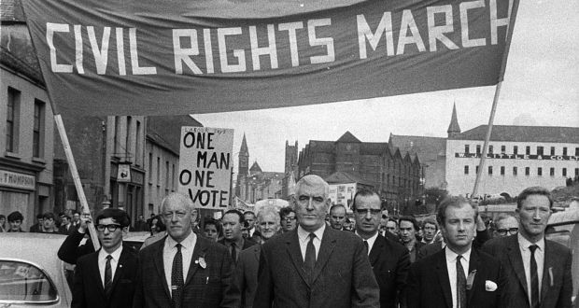
Here is a picture of the peaceful March proclaiming equal rights and that ended up in a massacre in the Bogside of Londonderry.

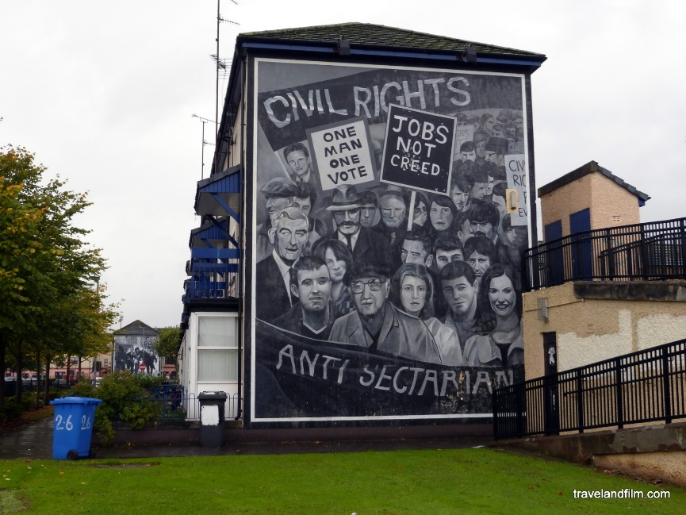
Here is a mural in Londonderry commemorating the civil rights march.

During the Troubles, in 1972, a massacre took place in Londonderry or Derry in a part of the city called the Bogside* (catholic district). It is known as Bloody Sunday. A peaceful protest march had been organised against internment among other things, during which 28 unarmed civilians (among whom there were children) were killed by the British soldiers.

In 1998, after campaigns for a second inquiry*, the Prime Minister Tony Blair established the Saville Inquiry that stated that ‘British troopers lost control… fatally* shooting fleeing* civilians and those who tried to help the civilians who had been shot by the British soldiers’ (Wikipedia quote), the civilians were not found to have posed any threat to the soldiers and should not have entered the Bogside.

In 2010 as the inquiry was over, the Prime Minister David Cameron apologized on behalf of *the British Government.
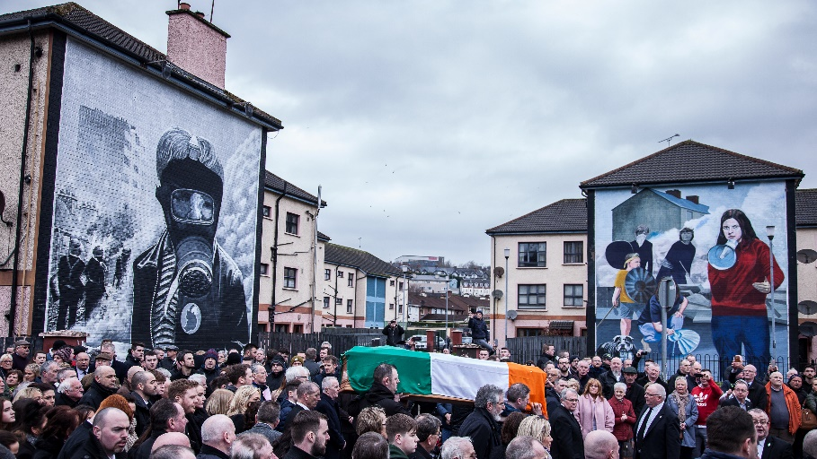
During the Troubles, a man called Robert Gerard Sands (Bobby Sands), who was a member of the Provisional Irish Republican Army, died on hunger strike in 1981 while he was imprisoned at HM Prison Maze in Belfast after being sentenced for firearms possession. He embodies the prisoners’ protest climax*. When in prison he was voted into the House of Commons as a Member of Parliament.
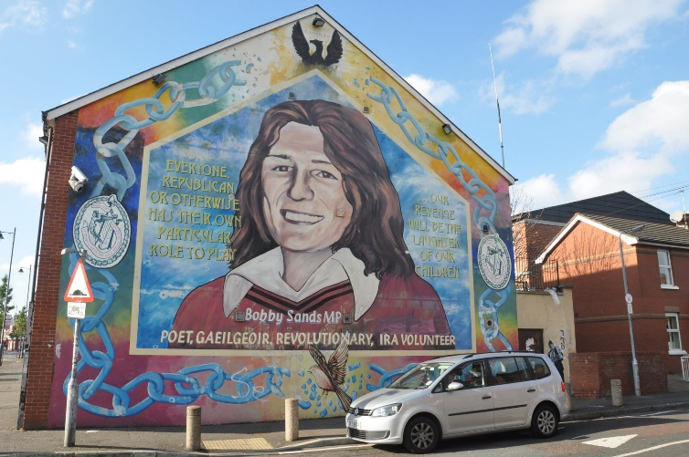
1998: The Good Friday Agreement
This compromise recognizes” the birth right of all the people of Northern Ireland to identify themselves and be accepted as Irish of British or both as they may so choose and accordingly confirm that their right to hold both British and Irish citizenship is accepted by both governments and would not be affected by any future change in the status of Northern Ireland.” This means the end of borders between the two Ireland and the end of the conflict.

Brexit implications: The consequences of Great Britain leaving the European Union are complicated for the Ireland/ Northern Ireland border and have been a large part of the negotiations between the European and British negotiators. To date, no compromise has been agreed, but several options are being discussed:
1) Re-establish the land borders between Northern Ireland and Ireland. 2) Put the border in the Irish Sea and maintain no land border between Northern Ireland and Ireland. 3) The UK stays in the European Union.
Discuss the advantages and drawbacks of the 4 options. For option 3 try to think as a Brexiteer!

