THE BLOG
03/18/2015 11:39 am ET | Updated May 18, 2015

Dangerous Speech is Not Free Speech or Even Hate Speech

By Barrett Holmes Pitner
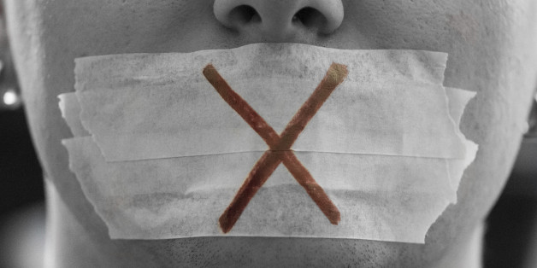
FL-photography via Getty Images

The video of Sigma Alpha Epsilon fraternity members at Oklahoma University chanting “niggers” would hang from a tree before ever joining their fraternity has sparked another furious national discussion over the limitations of free speech and the appropriate punishments for those who employ hate speech or dangerous speech.
And once again, too much of the media is focusing attention on the use of the “n-word” and not on the speech itself: a dangerous incantation and incitement to racial segregation, oppression and murder.
Last week’s Morning Joe on MSNBC was another example of this absurd theater of moral equivalences. The show’s hosts — Joe Scarborough, Mika Brzezinski along with conservative guest Bill Kristol once again attempted to explain to Americans that the problem with racism in America is that black rappers are indirectly brainwashing white youths to use the n-word. They argued that if black Americans do not want white Americans to continue referring to black Americans as niggers, then black Americans should stop allowing artists and record companies to use it.
Essentially, the onus is on black Americans to prevent white Americans from using inflammatory, insulting language that has been used to oppress and demean black Americans since the beginning of the cross Atlantic slave trade. Unfortunately, there does not appear to be a social awareness or obligation to minimize hate or dangerous speech in American society concerning this discussion.
Regardless of how repugnant we all may find the n-word to be, it should be clear to any rational person that this scandal isn’t about a black person saying “my nigga” in a rap lyric or even about a white youth saying it to his friends. This is about a group of youths gregariously chanting that those “niggers” should be hanging from trees. One usage expresses the support of murder, and one does not. This is how free speech transitions to hate speech and then to dangerous speech.
America needs to start a debate between free, hate and dangerous speech. Internationally this discussion has progressed further than here. In America the emphasis has been on hate crimes, which advocates for increased punishment for crimes perpetrated because of hatred of another’s race, religion or sexual orientation. Internationally the focus has shifted towards dangerous speech, which is a form of hate speech that clearly correlates to negative outcomes.
Susan Benesch, the Director of the Dangerous Speech Project in her paper, “Countering Dangerous Speech: New Ideas for Genocide Prevention,” says that “by teaching people to view other human beings as less than human, and as mortal threats, thought leaders can make atrocities seem acceptable — and even necessary, as a form of collective self-defense.”
The international emphasis of this discussion is centered around recent genocides and mass killings such as in Rwanda, Srebrenica and during the Holocaust; when the leaders of these atrocities publicized dangerous hate speech to disseminate ideologies of hatred to spur their followers to act, cow bystanders into passivity, and justify their crimes.
The hate speech used in these countries directly correlated to the commission of atrocities, and this discussion of dangerous speech could be beneficial in the United States. As a nation, America has tried to progress from the horrors of slavery, Jim Crow, lynchings and racial inequality while maintaining noble principles of free speech. Even now, the rather tepid addition of hate crime legislation constantly meets with resistance from many conservative lawmakers and parts of society. They argue a crime is a crime no matter its motives, and justice must be evenly meted by law enforcement. Coincidentally, the Department of Justice has just published its report finding that the Ferguson police department — and one would imagine many others in the country — is dangerously biased in its policing and treatment of its black citizens. It makes one wonder if any of the cops charged with protecting black communities were ever members of an organization or community that was comfortable referring to black Americans as niggers? The fraternity scandal demonstrates how racist, oppressive and dangerous traditions are still alive and well, and may contribute to the continued oppression of minorities.
As a society we must become more aware of the dangers that certain speech presents, and for the safety and well being of black Americans and other vulnerable citizens, we must explore more robust ways for distinguishing and punishing people for dangerous speech.
Oklahoma University appears to agree with this position since they have expelled two of the students leading the inflammatory recital, and banned that chapter of SAE from the campus.
However, the two expelled students and the remainder of the defunct chapter have now hired high-profile lawyer Stephen Jones and are considering legal action against Oklahoma University and its president David Boren over their “harsh” punishment and “tarnished” reputations.
They argue that they are being unfairly labeled as racists and bigots, and that they do not deserve being “tarred and feathered” — an interesting choice of words; especially, since the two students have since apologized for their actions through a letter prepared by their lawyer blaming intoxication for their actions. When has intoxication ever been an adequate excuse for abhorrent actions?
These young perpetrators should feel lucky that they’re not in jail. But the discussion in America has not progressed to a point where it sees dangerous speech — particularly racist incitement to violence — as a crime. The plaintiffs, along with too many Americans, are arguing that these “kids’” reputations have been unfairly tarnished. These arguments are either failing or not wanting to see the clear and present danger in their speech to black Americans.
Countries throughout Europe have seen the danger in certain hate speech and have created laws that punish racist incitement without compromising their democratic values on free speech. These laws protect Jewish and other minority residents and show that societies clearly value their safety and security in their countries. These laws have not prevented all acts of racism and violence from occurring, as the Charlie Hebdo attacks in France remind us, but they send the right message to vulnerable minorities and galvanize public and police support to prevent future atrocities.
If the Oklahoma chant happened in, say, Germany and the n-word was replaced with a derogatory epithet for the Jewish people, and the method of murder was changed from lynching to something employed by the Nazis, the perpetrators would be in jail right now and few outside the extremist right would argue that an injustice was done. How can so many in American society condone this incitement as youthful indiscretion and even redirect blame away from the perpetrators to the people who have had to suffer the oppression inflicted by those who spew these vile words?
America can learn something from the international community, where the legacy and dangers of certain types of speech are better understood. We too must find an effective way to monitor and forbid dangerous speech, without unjustly infringing upon freedom of speech. We should have started the discussion long ago.
Follow Barrett Holmes Pitner on Twitter: www.twitter.com/barrettpitner

