How to describe charts, graphs, and diagrams in the presentation
17.08.2018

Do you have to give a presentation? But do you know how to make it attractive to your listeners? Charts, graphs, and diagrams can help you cope with this task.
This kind of visual content helps your audience see what you are talking about. That’s why it’s so important to understand the way it works and know how to describe, charts, tables, and graphs correctly. You will also need this skill to be able to complete one of the IELTS tasks, which is usually to describe and discuss a diagram or any other visuals with figures and facts.
Whether you need to prepare for the English test or want to get professional advice on giving a presentation at work, certified tutors on Preply.com is here to help you. On our website, you can find a perfect private teacher according to your level, budget and time preferences. Study online whenever you want and enhance your business language skills with native English tutors from all around the world!

Find a perfect tutor
And now let’s see some useful words used to describe graphs and charts. But first of all, let’s have a closer look at the reason why visualization is so crucial for your presentation success.

Why do you need to use charts, graphs, and diagrams
A lot of presentations are focused on data and numbers. Sounds boring, right? Apart from essential business presentation phrases, charts, graphs, and diagrams can also help you draw and keep the attention of your listeners. Add them to your presentation, and you will have a profound evidence-based work.
When it comes to presenting and explaining data charts, graphs, and diagrams, you should help people understand and memorize at least the main points from them. As to the use cases, diagrams and other visuals perfectly fit for describing trends, making a comparison or showing relationships between two or more items. In other words, you take your data and give it a visual comprehensible form.

What is better to choose
There are so many different types of charts, diagrams, and graphs that it becomes difficult to choose the right one. The chart options in your spreadsheet program can also greatly puzzle.
When should you use a flow chart? Can you apply a diagram to presenting a trend? Is a bar chart useful for showing sales data? To figure out what to select, you must have a good understanding of the specific features of each type.
The rest of this article will show examples of different types of presentation visuals and explain in detail how to describe charts and diagrams.

Graphs, Charts & Diagrams
Data can be represented in many ways. The 4 main types of graphs are a bar graph or bar chart, line graph, pie chart, and diagram.
Bar graphs are used to show relationships between different data series that are independent of each other. In this case, the height or length of the bar indicates the measured value or frequency. Below, you can see the example of a bar graph which is the most widespread visual for presenting statistical data.
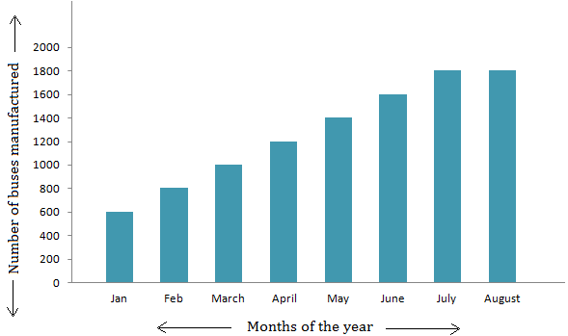
Line graphs represent how data has changed over time. This type of charts is especially useful when you want to demonstrate trends or numbers that are connected. For example, how sales vary within one year. In this case, financial vocabulary will come in handy. Besides, line graphs can show dependencies between two objects during a particular period.
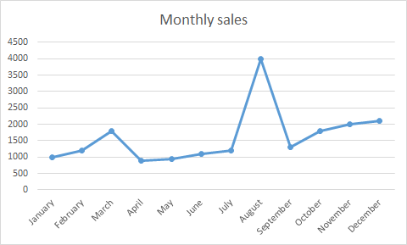
Pie charts are designed to visualize how a whole is divided into various parts. Each segment of the pie is a particular category within the total data set. In this way, it represents a percentage distribution.
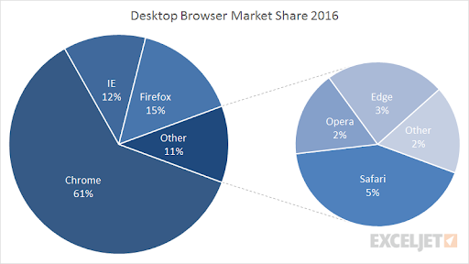
Diagram is a plan, drawing, or outline created to illustrate how separate parts work and overlap at the connecting points.
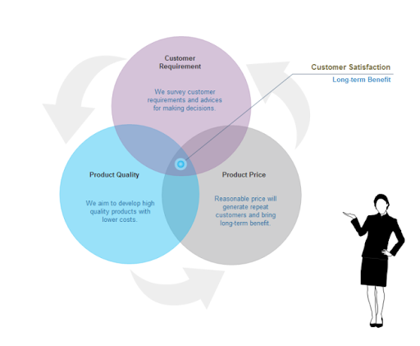

How to begin a description
Once you create a fascinating graph for your presentation, it is time to know how to describe graphs, charts, and diagrams. To catch your audience’s attention from the very beginning, you can use the following phrases for introduction:
- Let me show you this bar graph…
- Let’s turn to this diagram…
- I’d like you to look at this map…
- If you look at this graph, you will notice…
- Let’s have a look at this pie chart…
- If you look at this line chart, you will understand…
- To illustrate my point, let’s look at some charts…


Prepare to speak confidently
Improve your language skills with the latest articles, delivered weekly.

Subscribe
I agree with Terms of Service, Privacy Policy and Cookie Policy

How to describe diagrams and other visuals: naming the parts
To describe diagrams or any other type of graphs as clearly as possible, you should name each visual element. For example:
- The vertical axis shows…
- The horizontal axis represents…
- This curve illustrates…
- The solid line shows…
- The shaded area describes…
- This colored segment is for…
- The red bar…

How to describe bar graphs
Bar graphs transform the data into separate bars or columns. Generally, this type of visuals have categories on the x-axis and the numbers on the y-axis. So, you can compare statistical data between different groups.
The bar graphs show which category is the largest and which is the smallest one. Each group should be independent so that the changes in one do not influence others. The bars or columns can be drawn either vertically or horizontally, as it doesn’t make any difference.
The words used to describe bar chart are pretty similar to ones used for the line charts. Let’s have a look at the exam question to IELTS writing test, as it’s one of the major English-language tests for non-native English speakers in the world:
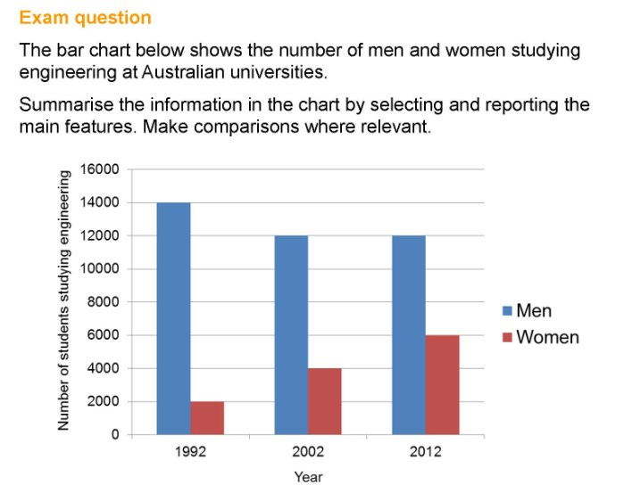
And here is an excellent example of writing about bar graphs prepared by the British Council as an answer to this exam question. You can also use the following vocabulary to talk about bar charts used in your presentation:
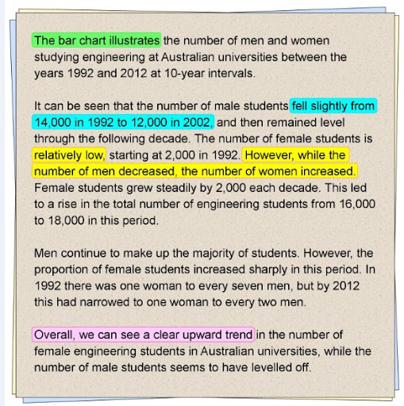

How to describe line graphs
Now, when you know how to describe bar charts, what about line graphs? This type of charts converts information into points on a grid that is connected with a line to represent trends, changes, or relationship between objects, numbers, dates, etc. These lines show movement over time affected by the increase or decrease in the key factors.
To express the movement of the line, you should use appropriate verbs, adjectives, and adverbs depending on the kind of action you need to show. For this, you should use the following vocabulary:
Verbs: rise, increase, grow, go up to, climb, boom, peak, fall, decline, decrease, drop, dip, go down, reduce, level up, remain stable, no change, remain steady, stay constant, stay, maintain the same level, crash, collapse, plunge, plummet.
Adjectives: sharp, rapid, huge, dramatic, substantial, considerable, significant, slight, small, minimal, massive.
Adverbs: dramatically, rapidly, hugely, massive, sharply, steeply, considerably, substantially, significantly, slightly, minimally, markedly.
There is also a list of adverbs to describe the speed of a change: rapidly, quickly, swiftly, suddenly, steadily, gradually, slowly.

Want to expand your business vocabulary to create winning presentations? Read our new article “50 Essential Business Presentation Phrases for Better Performance.”

To help you understand how you can use these words in your presentation speech, pay attention to the sample of a line chart with the exam question for IELTS:
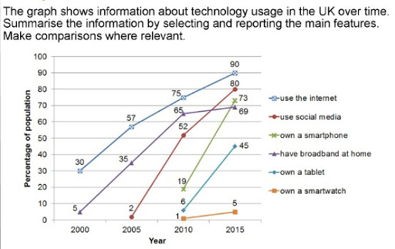
The appropriate vocabulary below will help you understand how to describe such charts:
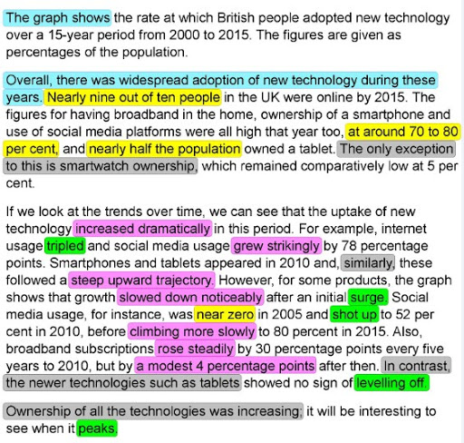

How to describe pie charts
The pie chart is primarily used to illustrate how different parts make up a whole. The best way to present your data in a pie chart is to compare the categories with each other. The following comparison words can be used interchangeably:
- to compare
- compared to
- as opposed to
- versus
- more than
- the majority of
- only a small monitory
- greater than
- less than
Here we have an example of a pie chart that represents how internet users aged 16+ prefer to browse the web:
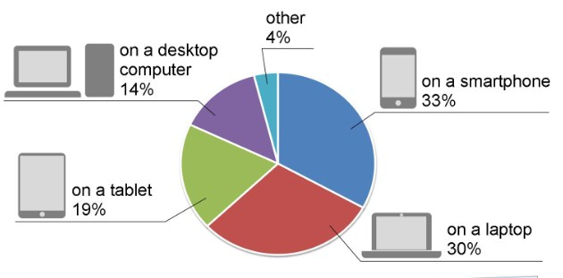
This example demonstrates the best way to summarize data by selecting and reporting the main features:
