Discrepancies at work

- Complete the missing letters in these countries:

I C _ _ _ _ D – N_R_ _ Y – F _ N _ _ _ D – S _ E _ _ N
IR _ _ _ _ D – Y _ M _ N – P _ K _ _ _ _ N – S Y _ _ A –
C H _ D – I _ _ N – – J _ R_ _ N –
2. Match the words with their definitions:
1. health | - A) become equal with
2. ranked | - B) intelligent
3. target | - C) what you have if you are not ill
4. lag behind | - D) assigned to a particular position in a list
5. catch up | - E) are late
6. earn | - F) identify
7. gap | - G) competent
8. skilled | - H) make money by working
9. smart | - I) difference
- Now, listen to the audio and correct this summary if necessary:
This article is about a report by the World Economic Forum that found out that in every country in the world, women are not yet equal to men, in terms of wages, health, education, job opportunities and political power.

- Listen again and complete the table:

Country | Rank
 | 1st
 | 2nd
 | 3rd
 | 4th
 | 5th
 | 28th
 | 140th
 | 145th

- What do these numbers refer to in the recording?

126 _____________________________
145______________________________
68_______________________________
10_______________________________
97_______________________________
4________________________________
2015___________________________
- Here is the transcription of the audio. Listen again and fill in the gaps.
Women in northern European nations are closest to equality with men _____ __________, education, health and education. That is the finding of a report by the World Economic Forum.
The United States ____________ 28th. On Friday, President Barack Obama announced the government will ____________large businesses to report how much they pay men and women. The __________ will be used to target companies that pay women less to do the same jobs.
According to the World Economic Forum report, women __________ continue _____ __________ __________men on wages. Based on current ____________, they will need 126 years to __________ ______, according to the report. Women are making progress. But they still only earn what men did 10 years ago, say the report’s authors.
The report measures the ____________ gap for women in 145 nations for health, education, economic opportunity, and political power. Women have not ___________ equality in any of the 145 nations included in the __________, says the report.
Women came closest to equality in four Northern European nations – Iceland, Norway, Finland and Sweden. Ireland __________ No. 5. At the bottom of the women’s gender ratings are Yemen, Pakistan, Syria, Chad, Iran and Jordan.
More women than men are ____________ colleges in 97 nations. But women make up a majority of ___________ workers in only 68 nations. Women control the majority of government and political positions in only four.
At last week’s World Economic Forum in Davos, Switzerland, Sheryl Sandberg, chief operating officer at Facebook, spoke about gender equality. “The reason to work ___________ equality – whether woman or man – is that it is better for you,” Sandberg said. “We should be doing this not because it’s the right thing, but because it’s the smart thing. … So do it because it will help you.” The World Economic Forum completed its worldwide 2015 gender gap survey in November.
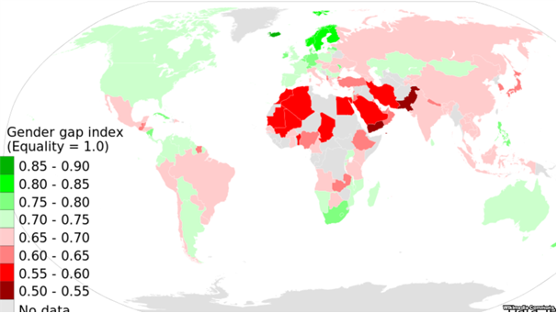

Women in northern European nations are closest to equality with men on wages, education, health and education.
That is the finding of a report by the World Economic Forum.
The United States ranked 28th. On Friday, President Barack Obama announced the government will require large businesses to report how much they pay men and women. The data will be used to target companies that pay women less to do the same jobs.
According to the World Economic Forum report, women worldwide continue to lag behind men on wages. Based on current trends, they will need 126 years to catch up, according to the report.
Women are making progress. But they still only earn what men did 10 years ago, say the report’s authors.
The report measures the gender gap for women in 145 nations for health, education, economic opportunity, and political power. Women have not achieved equality in any of the 145 nations included in the survey, says the report.
Women came closest to equality in four Northern European nations – Iceland, Norway, Finland and Sweden. Ireland ranks No. 5.
At the bottom of the women’s gender ratings are Yemen, Pakistan, Syria, Chad, Iran and Jordan.
More women than men are attending colleges in 97 nations. But women make up a majority of skilled workers in only 68 nations. Women control the majority of government and political positions in only four.
At last week’s World Economic Forum in Davos, Switzerland, Sheryl Sandberg, chief operating officer at Facebook, spoke about gender equality.
“The reason to work towards equality – whether woman or man – is that it is better for you,” Sandberg said. “We should be doing this not because it’s the right thing, but because it’s the smart thing. … So do it because it will help you.”
The World Economic Forum completed its worldwide 2015 gender gap survey in November.
I'm Anne Ball.
http://learningenglish.voanews.com/content/women-wages-lag-years-behind-men/3168954.html

Words in This Story
equity – n. fairness in how people are treated
opportunity – n. an amount of time or a situation in which something can be done
gender – n. male or female

