Her Blog Post About Uber Upended Big Tech. Now She’s Written a Memoir.

In 2017, Susan Fowler published a blog post describing the harassment she experienced at Uber, including multiple incidents of discrimination and corporate bullying.Credit...Mason Foster
When you purchase an independently reviewed book through our site, we earn an affiliate commission.
By Sheelah Kolhatkar
- Feb. 18, 2020

•
•
• • • WHISTLEBLOWER
My Journey to Silicon Valley and Fight for Justice at Uber
By Susan Fowler
In December 2015, Susan Fowler was settling into a new job as a software engineer at the technology-transportation company Uber when her boss sent her a series of disturbing chat messages. After asking how her work was going, Fowler’s manager, “Jake,” began complaining about inequities in his relationship with his girlfriend. “It is an open relationship, but it’s a little more open on vacations haha,” he wrote, to Fowler’s bewilderment. “She can go and have sex any day of the week. … It takes a herculean effort for me to do the same.”
It became clear to Fowler that Jake was propositioning her. She saved screenshots of the conversation and sent them to Uber’s human resources department so that he could be appropriately sanctioned. Instead, they told her that Jake was a “high performer,” and that it was his first offense, so they “didn’t feel comfortable giving him anything more than a stern talking-to.” It was up to Fowler to move to a different team within the company to get away from him. Both the inappropriate comments and the company brushoff are the kinds of experiences that women at all levels of the income spectrum have come to accept as inherent to the professional world. Rather than quietly tolerate it, though, Fowler, who was 25 at the time, decided to make a fuss.
What happened next received abundant news coverage: In 2017, Fowler published a blog post describing the harassment she experienced at Uber, including multiple incidents of discrimination and corporate bullying. The post went viral and the company started an investigation. Suddenly Uber, one of the fastest growing and most valuable companies in Silicon Valley, found itself at the center of several ethical and legal scandals, culminating in the departure of the company’s co-founder and C.E.O., Travis Kalanick.
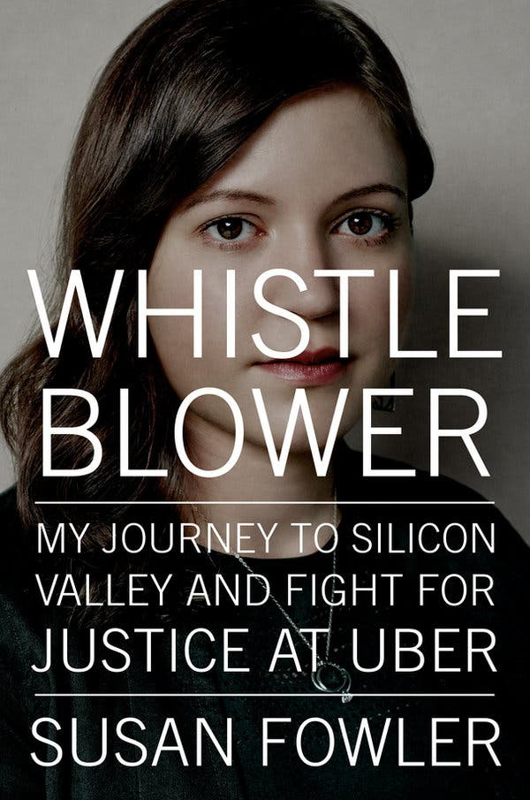
Image
Fowler’s revelations came eight months before The New York Times and The New Yorker published explosive allegations about Harvey Weinstein’s serial abuse of women, and helped catalyze the #MeToo movement. What is less well known is the remarkable back story that came before Fowler found herself at the center of these newsworthy events. “I wasn’t supposed to be a software engineer,” she writes in “Whistleblower: My Journey to Silicon Valley and Fight for Justice at Uber,” her sharp and engrossing memoir. “I wasn’t supposed to be a writer, or a whistle-blower, or even a college graduate, for that matter. If, 10 years ago, you had told me that I would someday be all of those things — if you had shown me where life would take me, and the very public role I would end up playing in the world — I wouldn’t have believed you.”
Advertisement
Continue reading the main story
Fowler grew up with six brothers and sisters in rural Arizona. Their father worked as a local evangelical preacher who studied foreign languages at night and dreamed of being a writer. Their mother home-schooled the kids, taught Fowler to play the violin and instilled a voracious appetite for books. Although there was, on occasion, no running water or food in the fridge, Fowler professes to have been oblivious to the fact that her family was poor. Eventually her mother had to get a full-time job as a bank teller to help pay the bills, leaving Fowler, who was a teenager by then, on her own. She says she didn’t fully realize how precarious the family’s financial situation was until later, when she was exposed to the ways that people outside of her community lived.
- Unlock more free articles.
Create an account or log in
Fowler does not provide a satisfactory explanation as to why she was unable to attend the local high school — one of several moments in her story when infuriating or baffling things happen to her that seem to be presented in an oversimplified or one-sided manner, which undermines the strength of her narrative. Still, fortified by her reading of Epictetus, Plato and Isaiah Berlin, Fowler turned these difficult circumstances into a potent form of motivation. After confronting the fact that she was on track to end up living in a trailer park and working minimum wage jobs, she studied the admissions criteria of colleges around the country and decided to teach herself the courses that she needed to get in. “It was as if someone had flipped a switch in my brain, as if something in my subconscious finally recognized that my survival was contingent on fighting for a better life, and every part of me was ready to win that fight.”
Incredibly, through ingenuity and hard work, Fowler ended up at the University of Pennsylvania, where she studied particle physics and helped design a circuit board for proton therapy cancer treatment. “It was a magical time in my life,” she writes. “I was on top of the world, and I’d never been happier.” But her trajectory takes a distressing turn when a male student with mental health issues whom Fowler says she barely knew seemed to start stalking her. The university’s handling of the situation, in Fowler’s telling, is shocking and worthy of investigation; it makes the school look almost as unprofessional as Uber. The episode derails Fowler’s plans to go to graduate school and become a physicist, which leads her to Silicon Valley.
“Whistleblower” is a powerful illustration of the obstacles our society continues to throw up in the paths of ambitious young women, and the ways that institutions still protect and enable badly behaving men. Fowler, who is now the technology op-ed editor at The Times, opens her book with a dedication to her infant daughter: “It is my hope that when you are old enough to read this book, the world described within it is completely unrecognizable to you.”

