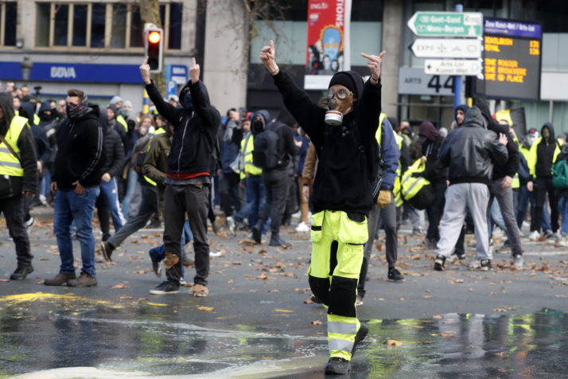
Yellow Jacket protesters in Brussels in December 2018 | Olivier Hoslet/EPA

Belgian transport union demands end to Yellow Jacket protests
Group urges Interior Minister Pieter De Crem to avoid ‘actions leading to unsustainable insecurity.’
By Judith Mischke
1/17/19, 11:38 AM CET
Updated 1/17/19, 5:21 PM CET
Belgian transport union Febetra has called on Interior Minister Pieter De Crem to put an end to Yellow Jacket protests because of the increasing risks to truck drivers.
In a letter to the minister, the union warns of "actions leading to unsustainable insecurity."
Isabelle De Maegt, a spokeswoman for Febetra, which represents Belgium's road hauliers and logistics providers, told Sudpresse Thursday that the union wrote to De Crem after truckers' experiences with road blockades set up by the French anti-government protesters, La Libre reported.
"We want the authorities to put an end to these blockages," De Maegt said. "Drivers and their vehicles are attacked. Drivers are being insulted, the trucks are being attacked. The tension is rising," she said, urging De Crem — who was appointed interior minister just over a month ago — to act.
At least 10 people have died in incidents related to the ongoing Yellow Jacket movement that began in France in mid-November as a popular protest against higher fuel taxes. The protests have since broadened into often violent street demonstrations against President Emmanuel Macron's government.
Belgium has seen an offshoot movement, and Belgian police this week formally identified a Dutch truck driver they suspect is responsible for the death of a Yellow Jacket protester in Belgium late last week.

