The Guardian - Back to home
Support The
Guardian Subscribe Search jobs
Sign in
Search
- News
- Opinion
- Sport
- Culture
- Lifestyle
- World
- Europe
- US
- Americas
- Asia
- Australia
- Middle East
- Africa
- Inequality
- Cities
- Global development

Véliberté, egalité, fraternité: is Paris's seminal bike share scheme out of date?
Cycling the city
Cities
Ten years ago, Vélib revolutionised Paris and inspired the world. But a new operator, higher prices and a hi-tech competitor have shaken its confidence
Cities is supported by
About this content
Chris Newens in Paris
Thu 7 Dec 2017 06.00 GMT Last modified on Fri 11 May 2018 13.06 BST

•
•
•
•

Shares
344

Comments
287

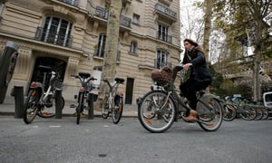
French student Alienor Saguez rides a Vélib public bicycle in Paris. Photograph: Francois Mori/AP
It was past midnight, I was new to Paris and the city’s municipal bike sharing system seemed something to be regarded with mistrust. It was the first time I ever used Vélib’. It’s hard to believe now, but in 2009 – before the Boris bike, before Uber, and in the bureaucratic world of France – being able to rent a bicycle from a machine using nothing but my credit card seemed too good to be true.
I took the bike out, paid the €150 (£130) deposit plus the 24-hour rental fee of €1, and pedalled on to the streets. The city’s Haussmann beauty sped by. It was like I could feel Paris shrinking just for me. The name, a portmanteau of velo (bike) and liberté (freedom) made instant sense. I only realised that I was cycling direct on to Charles de Gaulle Étoiles – one of the world’s most perilous roundabouts – when I was already there, counting three cars converge at me over the cobbles.
It is now 10 years since Vélib’ was established. The scheme’s trailblazing success has seen bike sharing reach almost 50 countries and roughly 1,000 cities worldwide.
Vélib’s success, and that of bike sharing in general, lies in what it allowed cyclists not to do – cycle home
Now Vélib’s operator, JCDecaux, which won the contract in part-exchange for advertising space around the city, has seen its tenure expire. Its successor, Smoovengo, a French-Spanish consortium that runs bike share schemes in 26 other cities, is ushering in a systemic overhaul, due to be complete by the new year. And with rival schemes based on a “dockless” model already popular in China recently being introduced, the French capital is gearing up for major change.

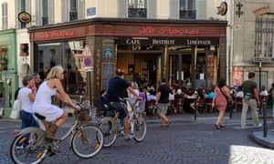

Facebook Twitter
Pinterest
Vélib’ now has one bike for every 97 Parisians. Photograph: Alamy
Advertisement
La Rochelle, in the 1970s, was the first town to successfully experiment with municipal bikes, though their famous vélibs jaunes operated on a trust system of “no stations, no padlocks”. This success was something of a miracle, even for the time – a similar scheme in 60s Amsterdam saw all the bikes stolen within a month.


Sign up for the Cityscape: the best of Guardian Cities every week
Read more
It was not until Lyon’s Vélo’v in 2005, also run by JCDecaux, that bike sharing, by using electronic docking stations and credit card deposits, was successfully implemented on a large scale.
Back then, Paris was not a cycling city. Despite a massive update of the city’s cycle paths in the mid-00s, just 1% of Parisians used bikes as their primary mode of transport. With the launch of Vélib’, things quickly changed. There were more than three million rentals in the first month; 200,000 Parisians had signed up within a year.
In part, this was down to ambition and its fastidious planning. Organisers divided Paris into blocks of 400 sq m and, considering factors from population and job density to existing transport infrastructure, concluded that it would take a minimum of 10,000 bikes for the system to work. Numbers have since more than doubled and Vélib’ has the highest market penetration of any bike share scheme in the world – one bike per 97 inhabitants.
Vélib’s success, and the success of bike sharing in general, also lies in what it enabled cyclists not to do. Namely, cycle. Parisians can cycle across the city – and then, should the weather turn, or they get drunk, or they simply don’t fancy it, they are not beholden to cycling home.



Facebook Twitter
Pinterest
Abandoned Vélib’ bikes recovered from the Canal Saint-Martin. Photograph: Charles Platiau/Reuters
Advertisement
The problem with a lack of responsibility is that, at some stage, someone has to pay, and keeping an even distribution of bikes has been one of the big challenges faced by all bike sharing schemes. How frustrating is it on a perfect spring morning to have planned a leisurely cruise from hilly Montmartre down to the bridges of the Seine, only to discover, scouring one empty Vélib’ station after another, that half the 18th Arrondissement has had the same thought?
Vélib’ recognised the need for redistribution teams from the beginning but underestimated the numbers required, with stations in the city’s outskirts often empty and those in its centre too full to park in. The battle has been constant, and though there was a drive to increase redistribution in 2011, official estimates only saw it improve 35% – which, if you’ve ever found yourself late for a job interview, rushing between empty stations deep in the banlieue, is often not enough.
Distribution is one of the main problems that Smoovengo’s overhaul is aimed at solving. The new bikes will offer a pile-up parking system, already trialled in Helsinki, on overcrowded stations. Also, a full 30% of the Vélib’ fleet will be electric, making it easier to reach the more elevated stations, such as those in Montmartre and Belleville, hopefully encouraging riders to use bikes for their tired end-of-day journeys as well as their morning ones.
Vandalism and theft have also marred Vélib’s progress, with initial rates far higher than JCDecaux had expected. Two years into the scheme, close to 80% of the bikes they had brought into use had needed replacing. Headlines were made when stolen Vélib’s turned up as far away as Romania, and when authorities dredged Paris’ Canal Saint-Martin last year no fewer than 98 were found in its depths.

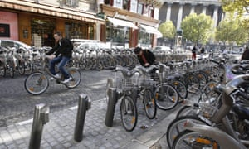

Facebook Twitter
Pinterest
City-centre bike stations are often too full to park in. Photograph: Bertrand Guay/AFP/Getty
Advertisement
Speaking to the New York Times, sociologist Bruno Marzloff explained the vandalism as an expression of resentment from Paris’ suburban and urban poor against the privileged class, perceived as the system’s main users.
With current costs as low as €29 a year – the cheapest public transport system anywhere in Europe, according to Le Monde – it’s hard to imagine even poorer citizens being priced out. But studies suggest that Vélib’ is a service used overwhelmingly by professional males under the age of 35 who live in the city centre.
Should the studies be accurate, they link to broader issues of integration throughout France and how a city’s geography can appear different depending on income and social class. The possibility that this might change with the overhaul seems unlikely – not least because subscription prices are predicted to rise.
At the same time, Vélib’ has had an unexpected impact on Paris’ young immigrant communities, with many stations visibly coopted as hangout spots. I asked a group of men from the Ivory Coast, gathered around a station just off the Rue du Faubourg Saint-Denis, about their feelings towards the bike share system.
“We use this station to rendezvous because it is convenient and does not cost anything,” said Hamed Traore. “But we’d never even consider using the Vélib’s themselves. I don’t know why. There are lots of other modes of transport in Paris, after all.”



Facebook Twitter
Pinterest
A Velib’ bike on display at the Paris fair in launch year – 2007. Photograph: Pierre Verdy/AFP/Getty Images
Advertisement
The days of bike share programmes needing stations may be numbered. New dockless systems, which have already proved massively successful in China, are currently being tested in Paris, with Hong Kong company GoBee Bike the first to hit the streets. These possess their own internal locking mechanism, operated through an app, which means they can be picked up and dropped off anywhere – a points system awards discounts for those who leave bikes in more convenient places.
Though small scale now, GoBee could come to present a massive challenge to Velib’. Its executives insist the company is to be thought of as a complement to the municipal system, but surely it is no coincidence that the new bikes have appeared in the months that the municipal bike system change-over, and the resultant closure of a number of docking stations, occurs.
Paris officials are taking the threat seriously with Jean-Louis Missika, the city’s deputy mayor for urban planning, comparing them to other start-ups like Uber and Airbnb that have significantly impacted Paris, and telling Reuters that regulation on dockless companies may soon be put in place.
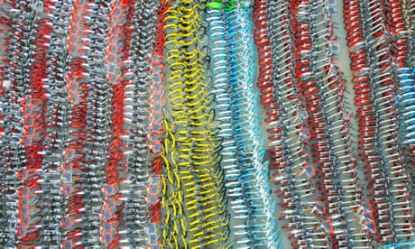

Uber for bikes: how 'dockless' cycles flooded China – and are heading overseas
Read more
“They saw a gap in the regulation and they jumped in. We cannot blame them, but that does not mean we will leave it at that,” he said.
Indeed, such a regulatory move seems increasingly necessary, as temporary station closures resulting in the change-over between JCDecaux and Smoovengo have been exacerbated by Velib’ employees of going on strike, hoping to hold on to their jobs, but leaving hundreds of bikes and stations falling into disrepair. Things have got so bad that the Paris City Council recently voted to reimburse the Velib’s 300,000 long-term subscribers: an admission that the system is no longer working. This has left the field open for companies such as GoBee bike to swoop in.
Even without regulation, a note of caution has been struck in the dockless bike share industry, with China’s third largest bike share company, Bluegogo, going bankrupt in November after over-estimating demand.
One thing is for certain: the overall number of cyclists in Paris is only likely to increase, be it through innovations by Vélib’ or dockless companies. If statistics have shown anything, it is the capacity of bike sharing schemes to create more cyclists. Indeed, there is nothing quite like the freedom of cycling from backstreet to boulevard, knowing that if the weather turns you can always take the Métro home.

