The Guardian - Back to home
Support The
Guardian Subscribe Search jobs
Sign in
Search
- News
- Opinion
- Sport
- Culture
- Lifestyle
- World
- UK
- Science
- Cities
- Global development
- Football
- Tech
- Business
- Environment
- Obituaries
Internet

Almost 50% of the world is online. What about the other 50%?
Connecting developed nations was relatively easy, but getting the rest of the world online will be far more difficult
- Exclusive: dramatic slowdown in global growth of internet access
- Life at the bottom of the global league of internet access
Alex Hern
@alexhern
Thu 18 Oct 2018 17.00 BST Last modified on Thu 18 Oct 2018 17.20 BST

•
•
•
•

Shares
81

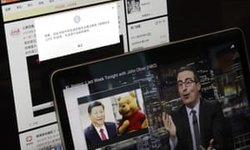
A screen shows a failure message saying a post could not be sent because ‘the content contains information that violates relevant laws and regulations’ on Sina Weibo next to a smaller computer screen showing a Last Week Tonight host John Oliver with a photo of Chinese President Xi Jinping and Winnie the Pooh. Photograph: Andy Wong/AP
There are two kinds of people in the world: those with internet access and those without. But the decades-long drive to convert the latter into the former is beginning to falter, the Guardian reveals today, prompting hard questions about whether connecting the world is even possible.
The reality, however, is far less black and white than the statistics make it sound. People access the internet in different ways, they use it for different things – and some of them even access different internets entirely. As William Gibson said, 25 years ago, the future is already here – it’s just not very evenly distributed.
The developed world, connected largely through the 1990s and 2000s, was relatively easy. Internet user growth rattled along at almost 20% at one point. In 2000, only three countries had penetration rates above 50%. Now, more than 100 do.
But in 15 countries fewer than 10% have access, and in another 50 countries, the connectivity rate is less than 30%. Getting these people online will be far harder.
Advertisement
Big technology companies are trying – but their approach means the internet in the developing world is often nothing like the rich world web.
Facebook, for example, realised that with the growth in mobile internet, a growing chunk of the world was offline not because where they live wasn’t wired up correctly, but simply because they couldn’t afford to buy a smartphone and pay for a data contract.
So Facebook began paying for them. The company’s Free Basics programme offers free internet in 22 nations, with access limited to a selection of just 20 or so websites, including Wikipedia, AccuWeather and, of course, Facebook itself.
The company has brought 100 million people online through this programme, and others like it, singlehandedly. But it’s not come without its downsides, some of them critical. In many of the countries where Free Basics has been most successful, the internet has been shifted into second place behind Facebook itself.

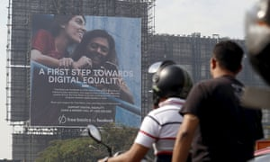

Facebook Twitter
Pinterest
Motorists ride past a billboard displaying Facebook’s Free Basics initiative in Mumbai, India, 2015. Photograph: Danish Siddiqui / Reuters/Reuters
In 2014, when quizzed, almost every internet user in Nigeria and Indonesia said they had also used Facebook the past month. Some said they had used Facebook, but not the internet itself.
Now, Facebook is having to grapple with the results of that. From ethnic violence in Myanmar, where the UN found that Facebook-spread misinformation played a significant role in exacerbating the situation, to religious violence in India, where Facebook-owned WhatsApp is used to forward vicious rumours faster than the truth can keep up, the company has found that replacing the internet comes with downsides as well as positives.
The internet isn’t just different in countries that must rely on Facebook for access. Subtle variations mean it is a different beast even in nations with lots in common.
For example, though the UK and US overlap on the anglophone internet, with media organisations, social networks and cultural phenomena flowing back and forth, there are differences. Take search engines, for instance: Google dominates in both nations, but is more popular in the UK. The difference is down to the enduring popularity of Yahoo in the US, where it maintains a market share almost three times higher than it has in Britain.
Move further afield, and even among developed nations with high internet penetration, experiences on the ground can be very different. Look at Germany, for instance, where Mozilla Firefox clung on as the number one browser until May 2017, and where it’s still the number two with 27% of the audience. In a fundamental way, the web looks different in Germany: it’s rendered using different technology, presented in a different window, and filtered by different extensions (as part of the Firefox dominance, Germany also has very high levels of adblocking, with almost one in three using an adblocker on their desktop computers).
It is hard to draw a fine line at what point a different ecosystem of browsers, sites and services starts to feel like a different web entirely, but wherever that line is, China is on the far side of it. The “Great Firewall”, the country’s strict web filtering regime, has led to a form of convergent evolution, as Chinese companies serving Chinese consumers have grown to fill the spaces vacated by the absent Silicon Valley giants. There’s “China’s Google”, Baidu; “China’s Amazon”, Alibaba; “China’s Twitter”, Weibo; and “China’s Facebook”, Tencent.

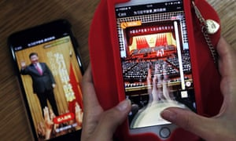

Facebook Twitter
Pinterest
A woman plays a viral Tencent smartphone game called A Great Speech, Clap for Xi Jinping in Beijing in 2017. Photograph: Andy Wong/AP
These days, though, those shorthand descriptions are grossly unfair. Tencent’s market cap is the same as Facebook’s; Weibo has 100 million more users than Twitter. Even Alibaba and Baidu, which haven’t hit the same heights as their counterparts, have grown to be giants in their own right.
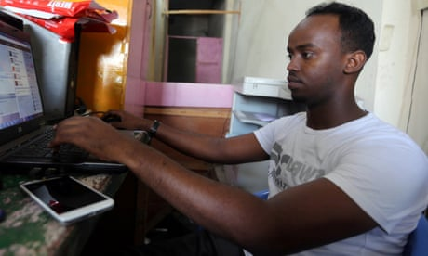

Life at the bottom of the global league of internet access
Read more
Those successes have helped internet filtering spread to other nations. Once, the threat of economic harm was enough to convince repressive regimes to allow a modicum of internet freedom. But China’s experience suggests more of a win-win approach: keep a controlling hand on the information diet of your population, and develop national tech successes in the process. Russia is already well down that road, with Yandex and VKontakte serving as that country’s Google and Facebook analogues. Other countries, from Turkey to Cuba, are eyeing up the same approach.
It’s not yet clear what lies behind the slowdown in internet growth. It may be that the low-hanging fruit has been picked, leaving regions and demographics that are increasingly hard to access; it may be that the big backers of growth, like Facebook and Google, are spooked by the chance that they will be blamed for the downsides of connectivity, not praised for its upsides. But whatever the reason, simply being online isn’t the end of the process: for many, it’s just the beginning.

