Annals of Technology

A Ride in Uber’s Self-Driving Car
By Erika Beras
September 16, 2016
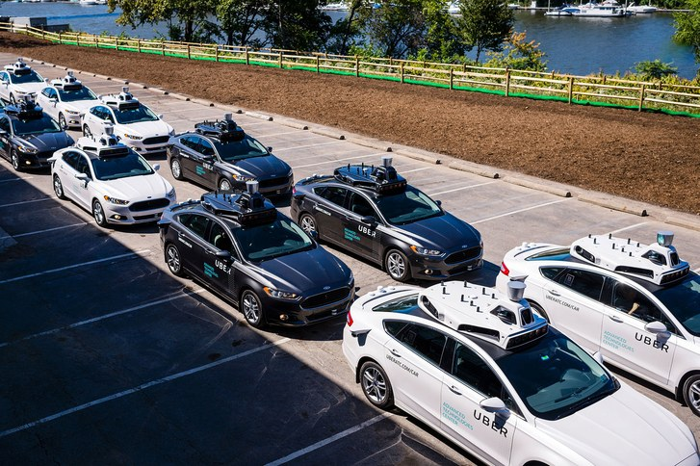
Is this the beginning of the end for Uber’s human drivers?
PHOTOGRAPH BY ANGELO MERENDINO / AFP / GETTY
One day they just appeared—Ford Fusions, some black, some white, with UBER stamped on the side. With their twenty cameras, seven lasers, and rooftop-mounted G.P.S., the self-driving cars stood out. People stopped and stared as they took trial journeys around Pittsburgh. That was in the spring. Now, in the waning days of summer, passengers hailing an Uber X may be picked up by one of the city’s many human drivers, or by one of a tiny fleet of autonomous vehicles. “I think that this is the most important thing that computers are going to do in the next ten years, is drive cars,” Anthony Levandowski, Uber’s vice-president of engineering, told a roomful of reporters on Monday, as the fleet prepared to ferry its first customers.
Inside, the cars look remarkably ordinary. They have two fewer cup holders than a standard Fusion, to accommodate two extra buttons in the center console, and, because of the equipment mounted on top, you can’t open the moonroof. In the trunk, a fan whirls continuously, cooling the extra machinery.
The car that I rode in, like the rest of the fleet, wasn’t fully self-driving. It was still in test mode, and Pennsylvania law requires a human in the driver’s seat, so two vehicle operators, a man and a woman, sat up front. The man handled the wheel while the woman balanced a laptop that displayed real-time images from the external cameras. They told me to tap the screen between their seats when I was ready to go. As we began moving, I followed along on the screen, which informed me when the car was in autonomous mode and when the operator had overridden the system and taken the wheel. This happened several times. First, we got stuck behind a double-parked truck, which he had to navigate around. Then a group of pedestrians crossed against a traffic light. Bicyclists, it turned out, were especially tricky for the autonomous system to deal with; from the top, they appear like pedestrians, from the bottom, like some kind of vehicle.
Uber’s program is in the early days of development. Michael Wagner, a robotics researcher at Carnegie Mellon University, told me that building a successful autonomous fleet—one that handles unexpected driving situations reliably and safely—takes an enormous amount of technical work. Wagner runs a company that tests the robustness of complicated software, including in consumer electronics and aerospace systems. “You don’t always know you’ve built it until you’ve gone out and done a whole lot of testing on it,” he said. In Uber’s case, the testing has been happening on Pittsburgh’s streets. For the past several months, fourteen test cars have been making daylong trips around the city, collecting information about the surrounding environment as they go. (According to Uber, one three-hundred-and-sixty-degree sensor generates more than a million data points per second.)
The city is in many ways a perfect proving ground, with its three rivers, four-hundred-odd bridges, and narrow, hilly streets. Its climate, moreover, is varied enough that Uber can test its vehicles in heat and cold, sun and snow. “We think that if we can really tackle Pittsburgh, then we have a better chance of tackling most other cities around the world,” Raffi Krikorian, the director of Uber’s Advanced Technology Center, said. Pittsburgh built its wealth on steel, suffered a depression in the late seventies and eighties, and has since based a new economy on the education, health, and tech sectors. Bill Peduto, the city’s current mayor, has made it easy for companies like Uber to operate in Pittsburgh and use its streets as a laboratory. “If you try to put regulations up front, they’ll have to be changed, and they’ll pretty much guarantee that the technology will just start somewhere else,” he said. Uber has not disclosed precisely how much it has sunk into this project, but Peduto told me that its total investment in the city—in employee wages, office space, and so on—amounts to “a couple hundred million dollars.”
Halfway through my ride, the operators offered to give me the driver’s seat. We picked a destination and I drove manually for about a half mile, then switched the car into autonomous mode. It maneuvered down a quiet road by the Allegheny River, over a heavily trafficked bridge, and onto a congested street. My foot hovered over the brake pedal the entire time—with a tap, I could make the car switch back over to manual control. The first few times we approached another car, I instinctively put my foot down. But, as the minutes went by, I let the car drive. It stopped, started, and signalled on its own. The steering wheel turned without my help.
So far, some of the loudest opposition to the autonomous-vehicle program has come from Uber drivers themselves. The company arrived in Pittsburgh only two years ago, but it already has four thousand of them in the city. Although its first self-driving fleet is small—just four cars available for hire, travelling short distances near downtown—it is likely to grow. By the end of the year, Uber plans to have many more of these vehicles picking up passengers and carrying them greater distances. Still, the day when the vehicles are totally autonomous, capable of driving unsupervised by humans, is some ways off. This fall, Pennsylvania’s Department of Transportation will draft a framework to govern further on-the-road testing, which officials there hope will be authorized by legislators. “That testing would be very broadly flexible,” Roger Cohen, the department’s policy director, told me. But, even with this flexibility, he said, it will be “a long time” before an Uber X pulls up to the curb with an empty driver’s seat.
- Erika Beras is a reporter and radio producer in Pittsburgh.
Read more »

