The Guardian - Back to home
Support The
Guardian Subscribe Search jobs
Sign in
Search
- News
- Opinion
- Sport
- Culture
- Lifestyle
Development 2030
Working in development

'They ensure each twin baby dies': the secret killings in central Nigeria
A shelter in Abuja is devoted to rescuing twins from death within remote communities convinced of their evil powers
Orji Sunday
Fri 19 Jan 2018 10.56 GMT Last modified on Mon 5 Feb 2018 15.02 GMT

•
•
•
•

Shares
305

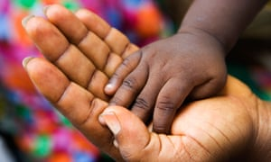
The Vine Heritage Home Foundation is currently home to 116 babies that have been rescued from tribal communities that kill twins at birth. Photograph: Frans Lemmens/Alamy
The room is filled with the cries of 30 or more babies. Steven Olusola visits each cradle, peering into their eyes in search of illness.
“They fall sick often because they never received any breastfeeding,” says Olusola, who founded Vine Heritage Home Foundation with his wife, Chinwe, 13 years ago. This is a sanctuary, for children rescued from one of the most remote areas of Nigeria, where being born a twin can be a death sentence.
Few Nigerians realise that the killings of twin babies continues. The practice is shrouded in secrecy, says Dioka Bridget, research fellow at the Centre for Igbo Studies, University of Nigeria.
“Many researchers don’t believe this practice takes place in [Nigeria] because it is absolutely absurd and ridiculous. And since most of us believe the stories to be fabricated, there is reluctance to approach or investigate the practice,” she says. “Now, as more media reports confirm [it], it could trigger the necessary investigation.”
The Vine Heritage Home Foundation, in the Nigerian capital of Abuja, would be a good place for any investigation to start. In 1996 Chinwe Olusola heard that a child would be offered as a sacrifice to trigger good harvest in that planting season. “I pleaded with them not to kill her and they allowed me to take her,” she says. “As more babies kept coming, it got to the point that my two-bedroom flat could not take us all. At that point we also had very limited support from individuals. The responsibility of caring for the babies became overwhelming and I resigned from my lecturing job at the University of Abuja.”
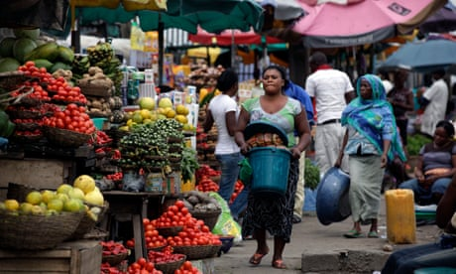

‘We are brought up to think suffering this violence is OK’: domestic abuse in Nigeria
Read more
The couple say that the killing of babies, usually twins, is still practised by a few groups within the Bassa Komo tribe. The tribespeople believe, according to Margret Ekesua, a missionary with Nigerian Pentecostal church Assemblies of God, that twins are “demons who suck their blood at night” and “predestined to kill either parent or both”.
The foundation’s efforts in persuading people to betray their communities and tip off missionaries when babies are at risk are the most difficult aspect of the rescue. “Through our locally trained informants and converts, we get information that a nursing mother has died or that a set of twins have been delivered. We trace the village and initiate negotiations with village leaders for the release of the child. We assure them that the children will return to them educated when the communities begin to accept them,” says Olusola.
But even with this strategy many babies still die. “Sometimes after pleading, long consultation and threat, the community won’t release the child and we know it’s over for that baby,” says Olusola. Some rescued babies die on the long journey to the city. Olusola says that some weeks no children will come in to the sanctuary, but other weeks may see as many as seven arrive. There are currently 116 children living there.
Advertisement
Hours from Abuja lies the beautiful village of Ubo Saidu, one of the Bassa Komo communities. Flocks of northern grey-headed sparrows sweep through green maize fields, while smoke from smouldering charcoal curls upwards as wives cook for their husbands.
“This land looks peaceful on the outside but it’s very violent on closer examination. That’s why aliens [outsiders] don’t know what happens in secret and they may not understand how twin-killing works,” says one local, who refuses to disclose his identity.
“Twin babies, according to our belief, are not humans. They are seen as danger to the existence of the entire community because our ancestors told us that they have strange powers. We see them as gods among men. So at birth, the entire village is alerted that a threat and perhaps an evil has been born into the community.”
He explains that in some places the witch doctor, upon the birth of twins, invokes his or her spirit as he performs customary incantations and enchantments. Communities employ witch doctors so that outsiders (journalists, government, missionaries) will struggle to trace the deaths to a particular individual or simply confuse them with general infant mortality.
“The consent of the witch doctors and community leaders is central to the practice in most communities and every native is aware of what is happening because at one point or the other their families have lost someone to the act. Some have lost four sets, some three, others more or less,” he says.
“At the place where the babies are born, the witch doctor feeds them with a secretly prepared liquid. He convinces the ordinary people in the community that the liquid is water and that the deaths of the babies actually result from the activities of the gods. The function of the water, he would say, is to keep the spirit of the twin in the family lineage. That’s far from the truth and that substance is highly poisonous. The women experience unbearable pain watching their babies die. In a few communities the women are tagged as unclean for giving birth to ‘forbidden beings’.”
A young person in one of the communities where twin killings take place tells me: “Our community believes that twins are very powerful. Their powers surpass the power of witches and wizards and all cult groups … Since the cults of witches and wizards rule here, they ensure that each twin baby dies. So they exercise mysterious magical powers in killing the babies. It appears strange to aliens but that’s how many of us have lived. A lot of families have lost babies after babies to this witchcraft … Christianity is gradually eroding this belief system, but it’s not over yet.”
Advertisement
He told me that in some places, emissaries – usually the witches – will be sent to strangle the babies or cover them with a broad calabash until they suffocate.

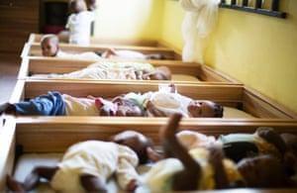

Facebook Twitter
Pinterest
The babies in the Vine Heritage Home Foundation in Nigeria have all been branded evil by their local communities. Photograph: C Oduah/Courtesy of VOA
In 2013, local newspaper reports sparked a government investigation. The 30-person government team said it was “apprehensive that besides the communities already reported on, there might still be others whose cultural practices, in so far as the welfare of the child is concerned, have not kept pace with civilised standards”.
Acting on an investigation that confirmed babies were still being killed, the National Orientation Agency created an awareness campaign and began a community dialogue. It involved traditional and religious leaders and community members from the six area councils in Abuja, with the aim of improving respect for the rights of the child and ending harmful cultural practices. But the campaign was cancelled due to a lack of funds, says Ruth Oguns, of the National Orientation Agency.
Josephine Alumanah, professor of anthropology at the University of Nigeria, believes far more time is needed to eliminate this practice. “This problem has nothing to do with making laws or telling the communities what to do. They need sensitisation and education and awareness,” she says. “You can’t convince people to change a belief system that has been with them for [hundreds] of years in a few weeks.”

