- Login
- Register
- Subscribe
- Rewards
- Search
- Video

- Home
- News
- Sport
- Business
- News
- UK
- World
- Politics
- Science
- Education
- Health
- Brexit
- Royals
- Investigations
- Telegraph
- News

Jesus Christ would be banned from UK universities today, Oxford professor says

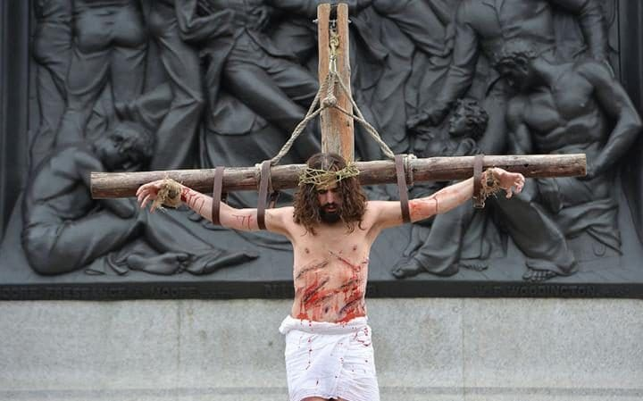Jesus: banned from UK universities?
- Hannah Furness, Arts Correspondent
30 May 2016 • 10:00pm
Jesus Christ would be banned from preaching on university campuses if he were alive today, after Britain became "too feeble" at standing up for free speech, a leading Oxford professor has said.
Professor Timothy Garton Ash, professor of European Studies at Oxford University, said the trend for "so-called safe spaces" had led to free speech being eroded from all sides, with even students insisting on shutting one another's opinions down.
Warning universities must "hold the line" against the "salami slicing" of free speech, he said it was time for the public to stand up against creeping legislation and self-censorship.
Speaking at the Hay Festival, sponsored by the Telegraph, Prof Garton Ash said he had identified four key areas of threat to free speech in Britain, including an increasing fear of violence against those who chose to share their opinions.
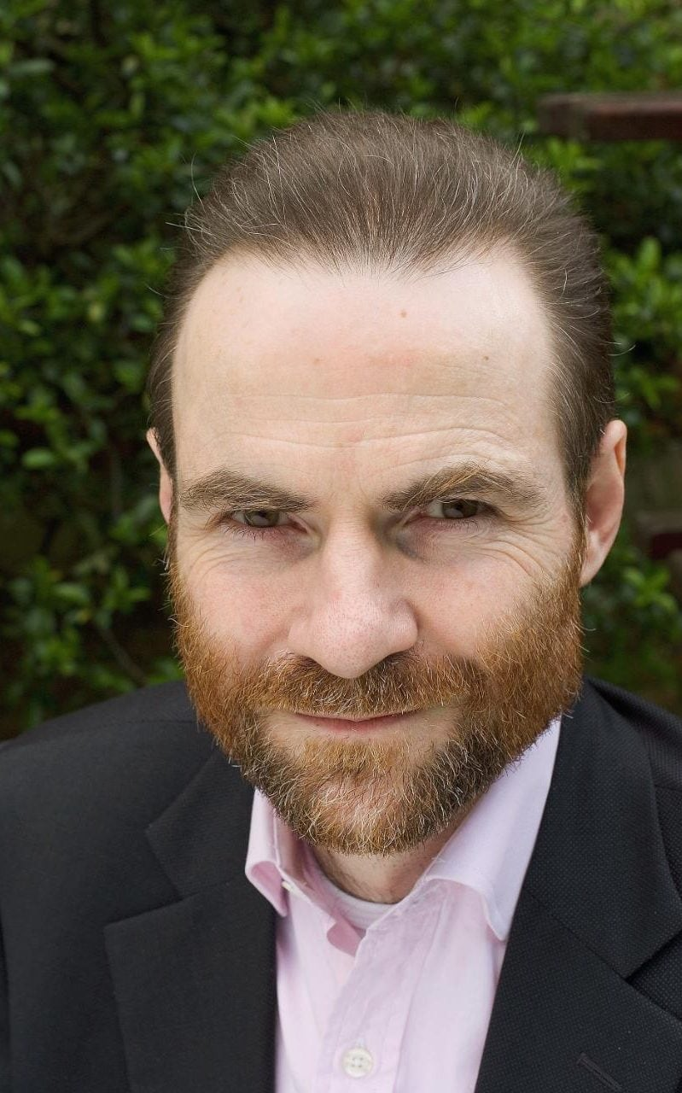
Professor Timothy Garton Ash Credit: Getty
Home Office legislation, he added, meant that universities were now encouraged to block even non-violent extremists from sharing their opinion, in a definition that could include some of the world's leading thinkers of centuries past.
He told an audience: "Some of you may know that in the new counter-terrorism legislation, the securocrats in the Home Office are trying to impose on universities a so-called prevent duty, which would call on us to prevent event non-violent extremists speaking on campus.
"Now non-violent extremists? That's Karl Marx, Rousseau, Charles Darwin, Hegel, and most clearly Jesus Christ, who was definitely a non-violent extremists. The Home Office wouldn't want him preaching on campus.
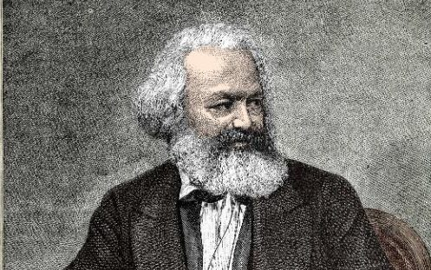
Karl Marx would also be banned from universities
"This is a real threat I think to free speech and one we have to fight back against."
Speaking of the key threats to speech, Prof Garton Ash, author of Free Speech: Ten Principles for a Connected World, said he had noticed an increasing trend for a small number of offended individuals to be able to shut debate down.
"It's not just the state saying that's offensive," he said. "It's a subjective veto act in which one person or a small group of people can say 'I'm offended' and that's held to be sufficient reason to not show that thing.
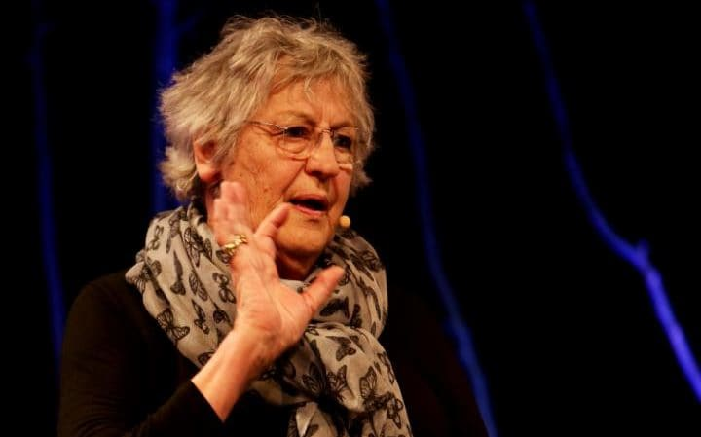
Germaine Greer speaks at Hay
"We have a big problem at the moment in our universities, because on the one hand we're under attack from our government like I said.
"And on the other hand there's a certain push from below from our own students demanding so-called safe spaces.
"You have to no-platform, say for example Germaine Greer.
"In my book, while we should really listen closely to our students, we have to hold that line.
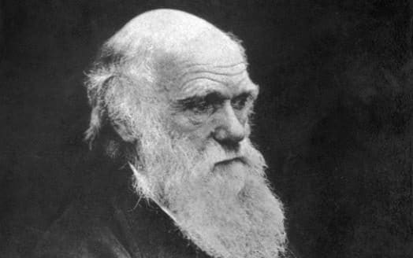
Charles Darwin may not be welcome either
"Because it's not just someone like me saying 'I don't want to hear Germaine Greer', because you don't have to hear Germaine Greer.
"What this is is actually a group of students saying to another group of students who want to hear Germain Greer 'no you can't do that'.
"It's one group of students censoring another."
He added: "We as universities really have to hold the line. Our free speech in Britain is gradually being salami-sliced away.
"This country, which in a way invented the modern version of free speech in the 17th century, is in my view much too feeble when it comes to standing up for free speech."
A Home Office spokesperson said: “The law is explicit that, in complying with the Prevent duty, universities must have particular regard to their duty to ensure freedom of speech and academic freedom. So in many cases, complying with the Prevent duty is as simple as ensuring there is an effective chair and a strong opposition voice.”
"There is no contradiction between promoting freedom of speech and taking account of the well-being of students, staff and the wider community, nor is there anything in the duty or any other aspect of Prevent which curtails genuine political debate.
"Protecting those who are vulnerable and at risk of radicalisation is a job for all of us and this Government is continuing to work in partnership with communities of all backgrounds to challenge those who spread hatred and intolerance.

