- Log in
- Join AFAR

- Home
- Travel Guides
- Japan
- Tokyo
The Incredibly True Story of Renting a Friend in Tokyo
Chris Colin2.19.2016
From the March/April 2016 issue

- Save



Photo by Landon Nordeman
When you’re alone in Tokyo and you need someone to talk to, do as the locals do: Rent a friend.

Share this article

- Save
It's muggy and I'm confused. I don't understand where I am, though it was only a short walk from my Airbnb studio to this little curry place. I don’t understand the lunch menu, or even if it is a lunch menu. Could be a religious tract or a laminated ransom note. I’m new in Tokyo, and sweaty, and jet-lagged. But I am entirely at ease. I owe this to my friend Miyabi. She’s one of those reassuring presences, warm and eternally nodding and unfailingly loyal, like she will never leave my side. At least not for another 90 minutes, which is how much of her friendship I’ve paid for.
Miyabi isn’t a prostitute, or an escort or an actor or a therapist. Or maybe she’s a little of each. For the past five years she has been a professional rent-a-friend, working for a company called Client Partners.
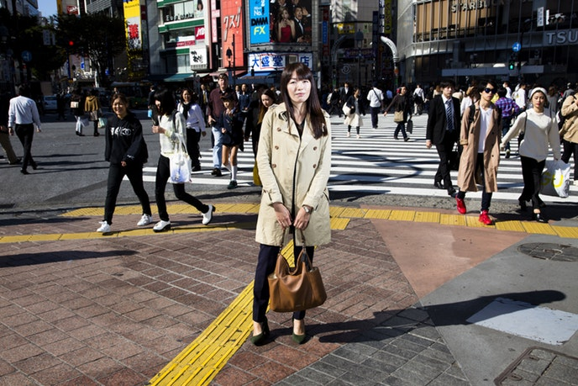+
Photo by Landon Nordeman
My lunch mate pokes daintily at her curry and speaks of the friends whose money came before mine. There was the head of a prominent company, rich and “very clever” but conversationally marooned at “hello.” Discreetly and patiently, Miyabi helped draw other words out. There was the string of teenage girls struggling to navigate mystifying social dynamics; at their parents’ request, Miyabi would show up and just be a friend. You know, a normal, companionable, 27-year-old friend. She has been paid to cry at funerals and swoon at weddings, lest there be shame over a paltry turnout. Last year, a high schooler hired her and 20 other women just long enough to snap one grinning, peace-sign-flashing, I-totally-have-friends Instagram photo.
When I learned that friendship is rentable in Tokyo, it merely seemed like more Japanese wackiness, in a subset I’d come to think of as interest-kitsch. Every day in Japan, it seems, some weird new appetite is identified and gratified. There are cats to rent, after all, used underwear to purchase, owls to pet at owl bars. Cuddle cafés exist for the uncuddled, goat cafés for the un-goated. Handsome men will wipe away the tears of stressed-out female office workers. All to say I expected something more or less goofy when I lined up several English-speaking rent-a-friends for my week in Tokyo. The agency Miyabi works for exists primarily for lonely locals, but the service struck me as well suited to a solo traveler, too, so I paid a translator to help with the arrangements. Maybe a more typical Japanese business would’ve bristled at this kind of intrusion from a foreigner. But the rent-a-friend world isn’t typical, I would soon learn, and in some ways it wants to subvert all that is.
Contrived Instagram photos aside, Miyabi’s career mostly comprises the small, unremarkable acts of ordinary friendship: Shooting the breeze over dinner. Listening on a long walk. Speaking simple kindnesses on a simple drive to the client’s parents’ house, simply to pretend you two are in love and absolutely on the verge of getting married, so don’t even worry, Mom and Dad.
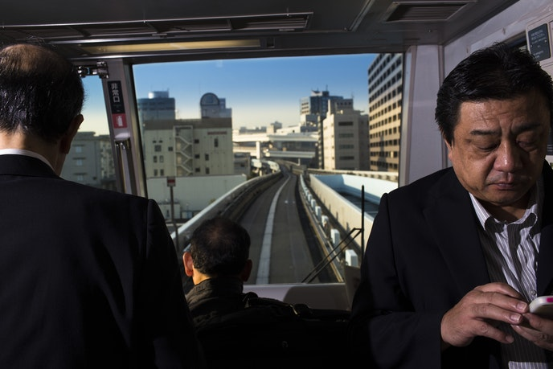+
Photo by Landon Nordeman
As a girl, Miyabi longed to be a flight attendant—Continental, for some reason—and that tidy solicitousness still emanates. She wears a smart gray skirt and a gauzy beige blouse over which a sheet of impeccable hair drapes weightlessly. She doesn’t care that I am peccable. She smiles when I smile, touches my arm to make a point. Her graciousness cloaks a demanding job. With an average of 15 gigs a week, Miyabi’s hours are irregular and bleed from day into night. The daughter of a doctor and a nurse, she still struggles to convince her parents that her relatively new field is legitimate. The money is fine but not incredible; I’m paying her roughly $115 for two hours, some percentage of which Client Partners keeps. So why does she do it? Miyabi puts down her chopsticks and explains: It helps people—real and lonesome people in need of, well, whatever ineffable thing friendship means to our species. “So many people are good at life online or life at work, but not real life,” she says, pantomiming someone staring at a phone. For such clients a dollop of emotional contact with a friendly person is powerful, she adds, even with a price tag attached.
So this isn’t secretly about romance? I ask. Not at all, she replies.
Two rules: no romance, no lending money. Also, be ready for all types of clients: Widowers who need someone to watch TV with. Shy guys who could use a dating coach. Shy gals longing for a shopping companion. And that one dude who just wanted a friend who’d do him the solid of waiting seven hours outside Nike to snag these fresh sneakers for him when they went on sale.
Then there are the fake boyfriends. At 35, “Hayato” had been facing intense pressure to find a wife and start a family. But it wasn’t happening, so he started a charade instead. A visit to his parents’ home was coming up, and with Miyabi’s help he concocted a whopper: that she was one of Hayato’s employees at his company and they had fallen in love. The two hunkered down in cafés to practice. Biographical details were learned, romantic quirks rehearsed. (As long as she was telling lies, he decided some general flattery wouldn’t hurt: Hayato’s so great and kind at the company, everyone there loves him.)
The day of the visit came, and lo, the parents bought it. Soon the fake relationship fake-graduated to a fake engagement.
“It was embarrassing,” Miyabi told me about the lying. “But watching his parents feel good when I said these nice things about him—it’s not all bad.” But all pretend-good things come to an end, and eventually a finale was written. In time, a heartbroken Hayato informed his parents that Miyabi loved her career more than she loved him—she’d transferred to a different branch, and that was that.
After lunch we walk out into the afternoon, our friendship nearly done. We stroll north, toward the cartoonishly packed intersection near the Shibuya subway station. Smiling young people pop into department stores. Schoolchildren huddle and cackle and retreat to phones and then re-erupt. Every other shirt shouts a bright, nonsensical slogan—i’m just being emo yesterday—capitalist exuberance overpowering sense. The whole scene looks like a promotional video for Japan. I believe Miyabi when she says her job is satisfying because of the personal connection. But I have to ask her why there’s such a demand for it on the clients’ side.
“Why?” Miyabi asks. “Because this is all a lie.”
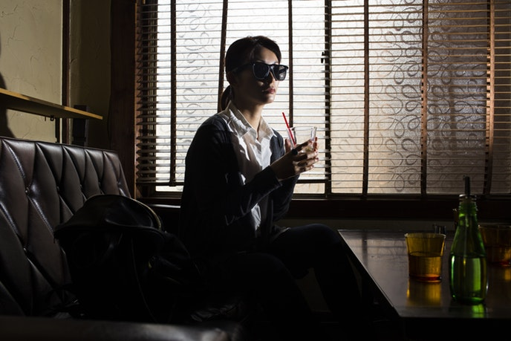+
Photo by Landon Nordeman
My friend Yumi is petite, with birdlike features made more birdlike by her human-scale fedora. She speaks good English but still wobbles, so her husband, Taka, joins us. They’re one of those sweet and unassuming couples that exist just to radiate koala-like gentleness. The afternoon is steamy, and we’re in the back of a tiny, dark izakaya in the city’s jumbly Sangenjaya neighborhood. It has been a day since Miyabi, the equivalent of a month in unmoored Tokyo time. I’ve walked through indomitably cute toy stores and narrow alleys thick with yakitori smoke. I’ve stared at white-gloved parking attendants and a poster showing a muscular cartoon figure winding up to punch someone. floor information, the poster said. From my miniature Airbnb studio, 10 stories up, I’ve tried unsuccessfully to snap everything into some kind of mental framework. Possibly I need some floor information.
I am grateful for my pretend friends.
As we nibble at pork with ginger, Yumi cheerfully tells me about the gigs she has had since joining Client Partners. (The six-year-old agency is the largest in Japan, with eight branches across Tokyo and another that recently opened in Osaka
.) There was the mystery writer who wanted her to read the novel he’d toiled away at for 10 years. Another man needed someone to talk with about his aging parents—not in person, but via months of emails. Like Miyabi, Yumi works weddings. For one she was hired to play the sister of the bride, a real living woman who herself was in a family feud that precluded her attendance. The mother of the bride was also a rental. The two impostors got along swimmingly.
Yumi explains that these are just the more theatrical gigs. The bulk of her clients? They just want basic, uncomplicated companionship. From Yumi’s vantage point, the breadth and depth of that need says something profound about her country.
There’s a word in Japanese, gaman, that translates roughly as stoic forbearance in the face of the unbearable. It’s a deep-seated Japanese value, this idea that you suck it up no matter what’s happening. A lot has been happening lately. Anxiety and depression spiked after the Fukushima nuclear disaster, according to the World Health Organization. The country itself is shrinking, its population plummeting and aging rapidly. And there’s the apparently growing problem of people who literally work themselves to death; a third of suicides have been attributed to overwork. All of that, Yumi and Taka say, but you act like everything’s fine. I gather this is the lie Miyabi was referring to.
Enter the rent-a-friend. Not a miracle cure, no. But maybe a pressure valve. “With us,” Yumi says, “people can talk about their feelings without worrying what their real friends think.”
+
Photo by Landon Nordeman
After lunch we roam a warren of 100-yen stores nearby—100 yen for a dusty old mug, for a weird cat statue, for a pouch of dried plums. Before parting ways at the subway entrance, we ask someone to snap our photo. That funny kinship that forms in front of a camera—the arms around each other, the shared self-consciousness—seems to happen for us, too. Yumi writes her address in my notebook, draws a cartoon of herself in her fedora. “Send me the picture,” she writes beside it. It’s almost as though she really means it.
During my time in Tokyo I develop a seamless routine of leaving the apartment, drifting vaguely toward the address on my phone, squinting confusedly, doubling back, eating some gyoza, and eventually stumbling onto my destination. On a drizzly Friday morning, my destination is the Client Partners headquarters, a small but airy suite in a nondescript Shibuya district office building. I rope my translator in for this, and we’re met by a round-faced woman in a long robelike garment. Maki Abe is the CEO, and for the next hour we sit across a desk from her and talk not about wacky interest-kitsch but about a nation’s spiritual health.
“We look like a rich country from the outside, but mentally we have problems,” Maki says. She speaks slowly, methodically. “Japan is all about face. We don’t know how to talk from the gut. We can’t ask for help. So many people are alone with their problems, and stuck, and their hearts aren’t touching.”
Maki and I bowed when we met, but we also shook hands. She brings it up later. “There are many people who haven’t been touched for years. We have clients who start to cry when we shake hands with them.”
It’s not that people lack friends, she says. Facebook, Instagram— scroll around and you find a country bursting with mugging, partying companionship. It just isn’t real, that’s all. “There’s a real me and a masked me. We have a word for the lonely gap in between that: kodoku.”
Maki attributes some of this to World War II. Spiritual consciousness was widespread before that, she says. “Harmony and helping each other was the national spirit. Now we’ve got selfishness instead. Not even people looking out for their own families, just themselves.”
I don’t know. I’ve yet to encounter a country without a similar narrative: Things were better, now they’re worse. Maybe the CEO of a friendship rental company can’t help but see fissures in the psychic landscape, or maybe the crisis is real. Regardless, Maki wants to fix it, one synthetic relationship at a time. Before we part, she stops me. Am I aware of Client Partners’ ultimate goal? I am not. To render itself unnecessary, she says.
With that, I head back out to the street, where the morning’s gentle rain has exploded into great lashing sheets. I watch for a while from under an awning, then decide to just get wet.
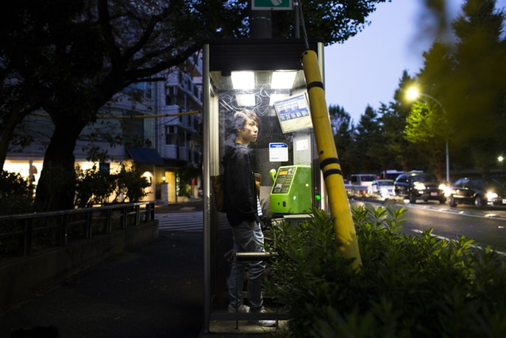+
Photo by Landon Nordeman
Tokyo is too overwhelming to explore with an unfocused mind. It will break that mind. But go in with something specific to mull, and this alternately churning and serene metropolis makes a pleasantly delirious backdrop. Me, I’m pondering a phenomenon I’ve flown 5,000 miles to understand. Inherent absurdity and all, the rent-a-friend industry holds for me the perverse promise of elucidating something real about friendship. By dragging this sometimes nebulous kind of relationship into the realm of commerce, I reason, maybe Miyabi et al can clarify things a bit.
Arguably I’m extra primed to hear the wisdom of people who are literally pros at being friends. I recently turned 40. When we were 22 or so, some close friends and I formed an only-half-joking kind of men’s group. Each month we’d meet at some grimy bar and aim for a structured discussion of how we were doing. The hope was to lock in some habits of openness that seemed lacking in the older men we saw, and to not become reclusive and boring and taciturn in middle age. Looking back now, I think, we also just wanted to keep friendship front and center, to never stop with the profound and idiotic nights at the grimy bars.
Nearly two decades in, I’d say we’ve avoided taciturn and reclusive, slipped a little on the boring and open front. But keeping friendship truly central? That’s a tall order. When you’re young, friendship is pure, a perfect and drunken snowflake. But as you get older, you see it can be complicated. Are my decades-old relationships truly superior to the commercial variety? OK, yes, duh. But they’re also more problematic. Even with one’s dearest friends someone invariably feels slighted or underappreciated now and then. Say what you will about rent-a-friends, but they bypass that whole dynamic. You don’t wonder about such a friend’s real feelings about you because you know them—in fact, they abide by a clearly delineated rate. With the matter of intention taken off the table, you’re free to focus on just having a nice time, on connecting in that very moment.
The rain lets up before I quite decide to trade my dearest amateur friends for platonic prostitutes, but I suppose I could put a few on notice.
My friend Yusuke is a guy. He stands out with a big mop of hair, a goofy laugh, and old-soul eyes—but when I meet my final friend tonight, it’s his maleness that distinguishes him most in a sea of female rent-a-friends.
By day, Yusuke sells furniture to corporate offices—a job, he concedes, that involves similar moves to being a friend. (“Express curiosity, open up about yourself first. It’s a show.”) But artifice and all, he’s a sweet and unguarded sprite of a fellow. He lived in various countries as a student and honed that easygoing adaptability common among kids who bounce around. He expresses curiosity and opens up.
We meet at the subway station in Yoyogi, and soon he’s leading me down a dark, wet street to a rickety okonomiyaki joint. Within a few minutes he’s showing me how to cook our own savory pancakes on the tabletop stove between us.
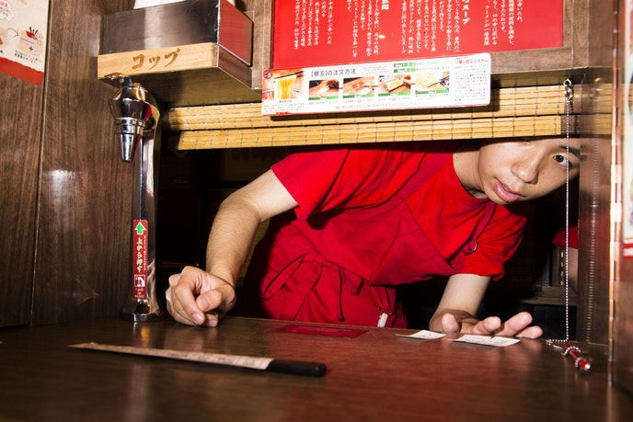+
Photo by Landon Nordeman
Like many Japanese people, he works 10-hour days, then often spends the rest of the night with those same colleagues, eating or drinking till all hours. Tonight, I gather, is a welcome break from that routine. We talk about childhood and relationships and aging. Because our temperaments align, or because I’m comfy in Tokyo by now, or because we’re both guys, conversation is easy. At one point the waiter offers us drinks. Yusuke says no alcohol on duty, and I realize I’d forgotten this was duty at all. I’ve paid for every word Yusuke has uttered, but I’m also certain we’ve forged something genuine. I have never hired a prostitute. Maybe it’s easier to believe their professed affections than I’d imagined, even as the money is right there in front of you. Maybe life is complicated. Maybe affection can be paid for and real at the same time.
Toward the end of our meal, Yusuke and I find ourselves discussing our grandfathers. It was meant to be a conversation about how social life evolves with age, but it becomes one about World War II. Both men had served, ostensibly, I suppose, trying to kill one another somewhere in the South Pacific. Each, we agree, had been deeply affected by those years. The sins of our respective countries could have plunged the meal into awkwardness, but in fact the opposite happened. In clumsily assuring each other of our good intentions—thoughtful questions! sympathetic nods!—we plunged into a funny sweetness instead.
When later we part ways, we’ll agree to stay in touch, and though we won’t, we’ll mean it in that moment. In the weeks ahead it will occur to me I’m grateful for all the elements—the smell of the pancakes, the talk of grandfathers, the wet pavement outside. Years from now, those things might just remind me of another wacky cultural phenomenon that took hold in Japan. Or they might summon the memory of this nice furniture salesman named Yusuke, a mop-headed guy who, for a couple hours one night in Tokyo, started to become a friend.
>>Next: The Tokyo Neighborhood You Need to Know

