The marriage squeeze in India and China
Bare branches, redundant males
Distorted sex ratios at birth a generation ago are changing marriage and damaging societies in Asia’s twin giants
Apr 18th 2015 |

KHAPs are informal local councils in north-western India. They meet to lay down the law on questions of marriage and caste, and are among India’s most unflinchingly conservative institutions. They have banned marriage between people of different castes, restricted it between people from the same village and stand accused of ordering honour killings to enforce their rulings, which have no legal force. India’s Supreme Court once called for khaps to be “ruthlessly stamped out”. In April 2014, however, the Satrol khap, the largest in Haryana, one of India’s richest states, relaxed its ban on inter-caste marriage and made it easier for villagers to marry among their neighbours. “This will bring revolutionary change to Haryana,” said Inder Singh, president of the khap.
The cause of the decision, he admitted, was “the declining male-female sex ratio in the state”. After years of sex-selective abortions in favour of boys, Haryana has India’s most distorted sex ratio: 114 males of all ages for every 100 females. In their search for brides, young men are increasingly looking out of caste, out of district and out of state. “This is the only way out to keep our old traditions alive,” said Mr Singh. “Instead of getting a bride from outside the state who takes time to adjust, we preferred to prune the jurisdiction of prohibited areas.”
The revision of 500 years of custom by its conservative guardians symbolises a profound change not just in India. Usually dubbed the “marriage squeeze”, the change refers both to the fact of having too many men chasing too few brides and the consequence of it in countries where marriage has always been nearly universal. Sex selection at birth is common in China and India. The flight from marriage—with women marrying later, or not at all—is long established in Japan and South Korea. But until recently, Asia’s twin giants have not felt the effects of sexual imbalance in marriage. Now they are.
The marriage squeeze is likely to last for decades, getting worse before it gets better. It will take the two countries with their combined population of 2.6 billion—a third of humanity—into uncharted territory. Marriage has always been a necessary part of belonging to society in India and China. No one really knows how these countries will react if marriage is no longer universal. But there may be damaging consequences. In every society, large numbers of young men, unmarried and away from their families, are associated with abnormal levels of crime and violence.
Missing girls, missing brides
The roots of the current squeeze go back a generation. Sex-selective abortions became common in China in the 1990s as a result of the country’s strict (now somewhat laxer) one-child-per-couple policy and a traditional preference for sons. A few years later they became increasingly common in India, also because of a preference for sons and helped by the growing availability of prenatal tests to determine sex. In 2010-15, according to the UN Population Division, China’s sex ratio at birth was 116 boys to 100 girls; in India the figure was 111. Though these ratios have fallen a little since their peaks, they are still far above the natural rate, which is 105 to 100.
As a result, enormous numbers of girls and women are “missing”—absent, that is, compared with what would have happened if there had not been sex selection. If China had had a normal sex ratio at birth, according to a report in 2012 by the UN Population Fund it would have had 721m girls and women in 2010. In fact it had only 655m—a difference of 66m, or 10% of the female population. India’s ratio is not quite so bad. Had it been normal, the country would have had 43m more women, or 7% more, than it actually did. Other countries practise sex selection at birth, but Asia’s giants overshadow all others. Together they account for 109m of the 117m “missing” girls and women globally in 2010. Calculations by Christophe Guilmoto of the Institute of Development Research, a think-tank in Paris, show that marriage patterns in India and China were still normal in 2010. But they will become badly distorted by 2020 (see chart).
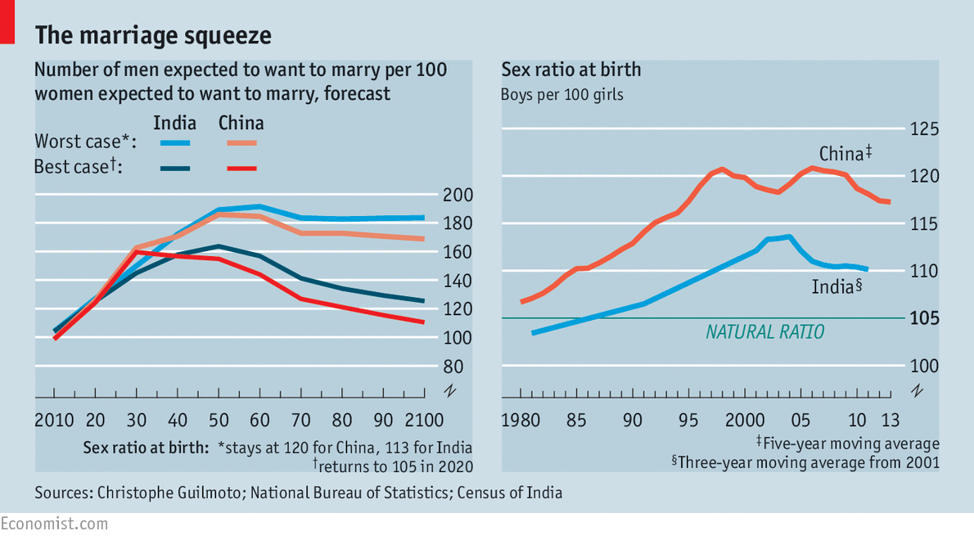
“Missing women” are only part of the explanation. Countries with normal sex ratios can experience a marriage squeeze if their fertility rates are falling fast. Fertility is important, because men tend to marry women a few years younger than themselves. In India the average age of marriage for men is 26; for women, it is 22. This means that when a country’s fertility is falling, the cohort of women in their early 20s will be slightly smaller (or will be rising more slowly) than the cohort of men they are most likely to marry—those in their late 20s (this is because a few years will have gone by and the falling fertility rate will have reduced the numbers of those born later). This may not sound like a big deal. But in fact between 2000 and 2010 the number of Indian men aged 25-29 rose by 9.2m. The number of Indian women aged 20-24 (their most likely partners) rose by only 7.6m.
Even if India’s sex ratio at birth were to return to normal and stay there, by 2050 the country would still have 30% more single men hoping to marry than single women. This is explained by a rapid decline in India’s fertility rate. But in China, where fertility has been low for years, the more gradual decline in fertility still means there will be 30% more single men than women in 2055, though the distortion declines after that. A decline in fertility usually benefits developing countries by providing a “demographic dividend” (a bulge of working-age adults compared with the numbers of dependent children or grandparents). But it does have the drawback of amplifying the marriage squeeze.
The problem is further accentuated by a so-called “queuing effect”. The length of a queue is determined by how many people join it, how many leave, and how long queuers are prepared to wait. In the same way, marriage numbers are a result of how many people reach marriageable age (the joiners); how many get married (the leavers) and how long people are willing to wait. In India and China, marriage remains the norm, so men keep trying to tie the knot for years.
Hence, a marriage queue in India and China builds up. At stage one, a cohort of women reaches marriageable age (say, 20-24); they marry among the cohort of men aged 25-29. But there are slightly more men than women, so some members of the male cohort remain on the shelf. Later, two new cohorts reach marriageable age. This time, the men left over from the previous round (who are now in their early thirties) are still looking for wives and compete with the cohort of younger men. The women choose husbands from among this larger group. So after the second round even more men are left on the shelf. And so on. A backlog of unmarried men starts to pile up. Just as you need only a small imbalance between the number of people joining a queue and the number leaving it to produce a long, slow-moving line, so in marriage, a small difference in the adult sex ratio can produce huge numbers of bachelors. They are called guanggun (bare branches) in China, malang (aloof and loopy)in Haryana and chhara (a derogatory term for unmarried men) in Punjab.
To make matters worse (for men, anyway), in rich Asian countries women are turning their backs on marriage altogether. Women with university degrees are more likely to marry late, or not at all, than those with primary education. Women who live in cities and have jobs are marrying later, or less, than rural women or those who work at home. Everywhere, female marriage rates are declining and the age of marriage is rising. In China, as women get richer and better educated, they are starting to repeat the behaviour of their Japanese and Korean sisters, pushing up the number of unmarried men.
 Lucky man
The combination of these factors in India and China will make their marriage squeeze especially acute and persistent—much more severe than it would have been in the case of distorted sex ratios alone. Mr Guilmoto calculates that, in China, for every 100 single women expected to marry in 2050-54 there could be as many as 186 single men (see chart); in India in 2060-64 the peak could be higher: 191 men for each 100 women. This assumes the sex ratio at birth does not change. But even if the ratio were to return to normal in 2020 (which is unlikely), the marriage squeeze would still be severe, peaking at 160 in China in 2030, and at 164 in India 20 years later.
A marriage squeeze of this intensity would be unknown in China and India and extraordinarily rare anywhere in history. America’s Wild West (or the fracking fields of present-day North Dakota) are rare examples of a society with huge numbers of excess men.
There may be positive side effects: a shortage of brides in India is causing dowry prices to fall in some areas, for instance. Overall, though, the impact is likely to be negative. A study by Lena Edlund of Columbia University and others found that in 1988-2004, a one-point rise in the sex ratio in China raised rates of violent crime and theft by six to seven points. The abduction of women for sale as brides is becoming more common. The imbalance is fuelling demand for prostitution.
There are few obvious remedies. If girls married earlier, it would increase marriage rates but would impede the progress being made by women in employment and education. Brides can be found in nearby countries. There are villages in China’s south-western provinces of Yunnan and Guizhou where many of the young women are Vietnamese or Burmese because local girls have gone to work in cities. A state-run newspaper, Beijing News, recently offered advice about the ten best places for Chinese men to find brides abroad (Ukraine, apparently, is promising). But this merely transfers the problem from one place to another. China and India are so vast that no marriage migration could ever be big enough to satisfy demand.
Bare branches on the family tree
If—a big if—marriage pairing were to become more symmetrical (ie, college graduates marry one another, and so on), then at least the burden of non-marriage would be spread more evenly. In India and China, women tend to “marry up”—illiterate women marry men with primary education; primary-school women marry men with secondary education; and so on. As a result, men at the bottom of the pyramid, and women at the apex, find it especially hard to find spouses. So the marriage squeeze does not affect everyone equally. It disproportionately hits illiterate men and does not do much to help graduate women (shengnu, or leftovers, as they are called in China).
But overall, changing the patterns of marriage would merely moderate a squeeze which is likely to continue for decades. China has eased its one-child policy, and the sex ratio at birth has fallen. But because the marriage squeeze is the product of other factors, too, it will continue even were the sex ratio at birth to return to normal. If that happened, Mr Guilmoto reckons, over 21% of Chinese men would still be unmarried at 50 in 2070, while in India the figure would be almost 15%. Three generations after sex-selective abortions began, their impact will still be felt.
India and China will change hugely as they become wealthier and better educated in coming decades. But few changes will be as momentous and persistent as the one now beginning: universal marriage will become a thing of the past.
Sources cited in this article:

"Skewed sex ratios at birth and future marriage squeeze in China and India, 2005-2100" by Christophe Guilmoto. Demography magazine, 2012

UNFPA report: "Sex imbalances at Birth"

Research on impact of marriage asymmetry: "Potential (Mis)match? Marriage markets amidst sociodemographic change in India", by Albert Esteve, Ridhi Kashyap and Joan Garcia-Roman, Demography magazine 2015

Research on khaps: “Sex ratio, Khaps and Marriage reform” by Ravinder Kaur, Economic and Political Weekly, August 2nd 2014

See also "Mapping the adverse consequences of sex selection and gender imbalance in India and China" by Ravinder Kaur, Economic and Political Weekly, August 3, 2013

"More Men, More Crime: Evidence from China’s One-Child Policy" by Lena Edlund, Hongbin L,i Junjian Y,i Junsen Zhang. In Forschungsinstitut zur Zukunft der Arbeit Institute for the Study of Labor, Discussion Paper Series, 2314, December 2007

Sex ratios at birth and other demographic numbers from the UN population division website

Dig Deeper:

Gendercide (March 2010)

The worldwide war on baby girls (March 2010)

Asia's lonely hearts (August 2011)

The flight from marriage in Asia (August 2011)

