Consumer electronics in China
From followers to leaders
Why the Chinese will increasingly set the trends in gadgetry
May 30th 2015 | SHANGHAI |
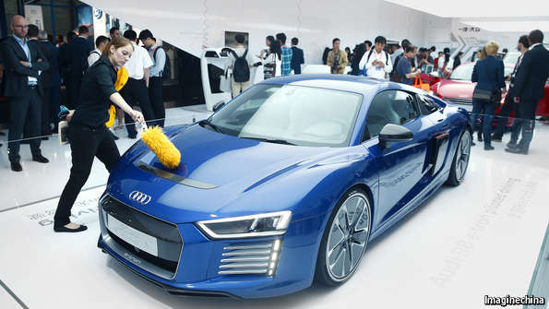 Introducing the latest in feather-duster technology
IT IS a courageous foreigner who drives on China’s roads. A combination of tens of millions of inexperienced drivers and a general disregard for traffic rules makes them among the world’s deadliest. Braver still would be the car manufacturer that dares to put a car loaded with automated-driving features on such roads. Western notions of what is a safe distance between cars mean little in China. How could an autonomous vehicle conceived for orderly Germanic roads cope with such anarchy?
Nevertheless Audi was this week giving journalists demonstrations of hands-off motoring through the frantic Shanghai streets. Its test cars were in town for a giant consumer-electronics fair, where it announced deals with Baidu, China’s biggest search-engine and mapping firm, and Huawei, a telecoms-equipment manufacturer, to kit out its connected cars of the future.
The German firm’s faith in China’s digital boom may be well placed, if this week’s convention is a guide. This is the first year that a version of the Consumer Electronics Show (CES), which is held every year with much fanfare in Las Vegas, has been held outside America. Hitherto, trends in consumer gadgetry have typically taken off in America first, followed by the rest of the rich world, and then in emerging markets like China. That may be changing.
Size is one reason. America’s Consumer Electronics Association, which stages the CES, forecasts that the Chinese market for electronic goods will grow by 5% to $281 billion this year, and at current growth rates will overtake America’s next year. A big market gives firms added incentive to try out new devices there early.
But there are other reasons besides size to expect the Chinese consumer increasingly to be the trend-setter, rather than the trend-follower, in electronics. First, take autonomous and “connected” cars. The average Audi buyer in America or Europe is in his 50s, but in China he is a digitally-addicted 36-year-old. So models with such advanced options are likely to become widespread in China first. Fully driverless cars, in particular, may take off quicker than in litigious America or risk-averse Europe.
Second, the Chinese have taken to mobile commerce with gusto. Apple is reported to be in talks with Alibaba, a local e-commerce firm, to bring its mobile payment system to the Middle Kingdom. Consumers who have quickly got used to shopping on mobile devices also seem likely to be enthusiastic adopters of smart watches and other wearable devices.
The Chinese people are turning out to have a greater affinity for gadgetry than even the Japanese; and Chinese companies are innovating furiously, producing all manner of devices, one of which may, perhaps, turn out to be the next Sony Walkman. JD, a successful online retailer akin to Amazon, this week showed off a voice-controlled gadget, dubbed the DingDong Smart Speaker, essentially a radio that plays whatever you tell it to—music, news, weather, or whatever. At a gathering of its own in Beijing this week, Lenovo, now the world’s biggest computer-maker, unveiled its plans for the first smart watch with two screens—an ordinary one, and one that uses optical reflection to create a much bigger virtual display. It also unveiled plans for a smartphone with a built-in laser projector and infrared motion detector that is capable of projecting what is, in effect, a giant touch screen.
Chinese electronics firms still have a reputation for simply copying Western designs. And there was still evidence of this at the CES gathering in Shanghai: plenty of lookalikes of Google Glasses, Apple Watches and iPads were to be seen at vendors’ booths. However, there were also a surprising number of original inventions on display, with a chance of making it in foreign markets. This opportunity is beginning to change Chinese firms’ attitudes towards intellectual-property protection. Chinese inventors backed by venture capital, who are hoping to launch their products in America, are beginning to patent them, realising that this boosts the valuation that investors put on their firms.
Consider The One, a brilliantly conceived electronic piano that integrates with music libraries accessed via smartphones and tablets. Many people give up trying to learn the piano because of the tedium of learning to read off manuscripts. The keys on this nifty piano light up in progression, to help pupils figure out which keys to press, and it uses tricks adapted from video games to help pupils eventually wean themselves off the lights and become able to read music. Ask Ben Ye, the firm’s founder, whether his hot-selling invention is safe from local copycats, and he says no. So why is his firm paying hefty licensing fees to foreign music publishers, to use their songs? We pay for the intellectual property we use because we want to go global, he says.

