The news: gathering and delivering

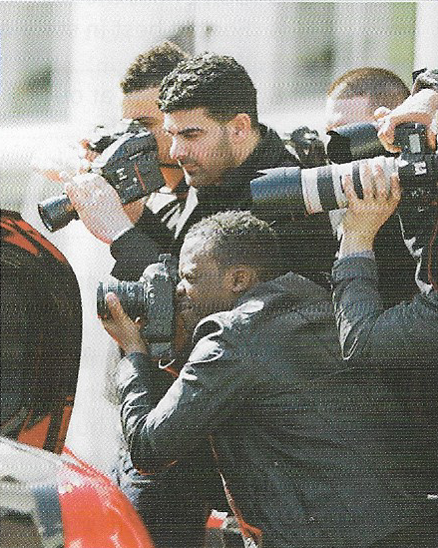
Gathering the news
There are a number of different types of journalism: print journalism, broadcast journalism [radio and TV], online journalism – and, increasingly, citizen journalism: this is where ordinary citizens use social media to report, photograph and share news with others.
Professional journalists gather news in a number of ways. They may get stories from pressure groups which want to air their views in public. [express their opinions] Journalists also attend press conferences where politicians or others may issue a statement or press release. A person seeking publicity will try to include a soundbite in what they say. [short memorable sentence or phrase]
Journalists also hunt for stories by tapping useful sources [making use of people or organisations which regularly provide news] and by monitoring international agencies like Reuters. The more important story is, the more airtime it will achieve and the more column inches it will be given in the newspaper or on the webpage: in other words, the more coverage it will receive. [media attention] Paparazzi follow celebrities or public figures and try to get photographs of them for newspapers and magazines.

Delivering the news
A rag is an informal word for a newspaper and it suggests that it is not of very high quality. The gutter press is a disapproving term used about the kind of newspapers and magazines that are more interested in crime and sex than serious news.
Journalists produce copy, which has to be ready for a deadline. With printed newspapers, when everything is ready, the newspaper goes to press.
Previous issues of a newspaper are known as back copies. These are usually accessible in an online archive. A story that is only to be found in one newspaper is an exclusive or scoop. All newspapers or TV news channels hope to run a story that no one else has discovered. A major story can be said to hit the headlines on the day it is published. At that time, the story breaks or becomes public knowledge. A newspaper may be taken to court for libel or defamation of character if it publishes an untrue story that, for example, wrongly accuses someone of something.
Journalist of different political persuasions will put their own gloss / spin on a story. [present it in their own way] Some journalists gather stories by muck-raking. [collecting scandal] Generally, newspapers like to make stories sound more dramatic by using words like heroic and triumph, even for some occurrence that is quite ordinary. [happening, event]

Exercises
A Match the two parts of the collocations.
1 air a groups 2 issue b conference 3 muck c bite 4 press d journalism 5 pressure e raking 6 citizen f sources 7 sound g a statement 8 tap h your views
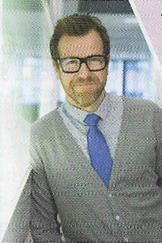
B Fill in the gaps with words from the first page.
The way journalists work has changed a lot over the last twenty years. When I started out as a junior reporter, we had to produce all our …………… to very tight ………………… , because we had to make sure it was all in place before the paper ………………….. to press, ready to be in the shops the next morning. Now a lot of what we do is online, which means we can publish a story only a few minutes after it……………… It’s much easier to find old articles to check facts, too, because most newspapers have an online ………………………. that you can access. People expect a lot more photos these days, though, which is why we rely on the ………………… so much.
C Answer these questions about words and expressions.
1 What two words might describe the kind of story that a journalist dreams of getting? 2 What two expressions refer to the moment of publication of a big story? 3 Which two crimes are mentioned and what do they consist of?
D Rewrite these sentences so that they mean the same thing, using the words in brackets.
1 Every news report inevitably gives its own particular view of events. (spin) 2 I have to find some articles from some previous editions of The Times. (back) 3 The TV news yesterday broadcast something about my favourite singer. (ran) 4 The floods took up more space in the papers than any other story this week. (column) 5 Politicians are always ready and willing to give their opinions to the press. (air) 6 The story about the scandal surrounding her uncle broke on her wedding day. (hit) 7 Any newspaper does all it can to prevent being sued for libel. (character) 8 Muck-raking is a characteristic activity of an inferior kind of newspaper. (press)
E Choose the best word to complete the sentences.
1 The President will be holding a press release / conference this afternoon. 2 The story broke / hit last night when it was the first item on the TV news. 3 Politicians are usually not slow to seek coverage / publicity. 4 The story has had a lot of print / media attention. 5 The story received a lot of airtime / soundbite on the radio. 6 Social / Print media have encouraged the development of citizen journalism. 7 Ricky deserves to be called a hero / rag - he acted with great courage. 8 Unfortunately, muggings are an everyday occurrence / triumph in this part of town.

