Idea
Growth share matrix
A framework to help companies think about the priority (and resources) that they should give to their different businesses
Sep 11th 2009 |
The growth share matrix is a framework first developed by the Boston Consulting Group (BCG) in the 1960s to help companies think about the priority (and resources) that they should give to their different businesses. Also known as the Boston matrix, it puts each of a firm's businesses into one of four categories. The categories were all given memorable names—cash cow, star, dog and question mark—which helped to push them into the collective consciousness of managers all over the world.
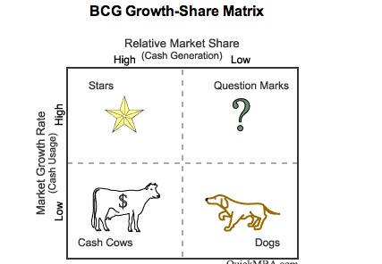
The two axes of the matrix are relative market share (or the ability to generate cash) and growth (or the need for cash).
• Cash cows are businesses that have a high market share (and are therefore generating lots of cash) but low growth prospects (and therefore a low need for cash). They are often in mature industries that are about to fall into decline.
• Stars have high growth prospects and a high market share.
• Question marks have high growth prospects but a comparatively low market share (and have also been known as wild cats).
• Dogs, by deduction, are low on both growth prospects and market share.
The conclusions drawn from such an analysis are to transfer the surplus cash from a conglomerate's cash cows to the stars and the question marks, and to close down or sell off the dogs. In the end, question marks reveal themselves as either dogs or stars, and cash cows become so drained of finance that they inevitably turn into dogs.
The trouble with this colourful schema is that classifying businesses in this way can be self-fulfilling. Knowing that you are working for a dog is not particularly motivating, whereas working for an acknowledged star usually is. Moreover, some companies misjudge when industries are mature. This may lead them to decide that businesses are to be treated as cash cows when they are in fact stars. One such industry was consumer electronics. Considered by many to be mature in the 1970s, it rebounded in the 1980s with the invention of the CD and the VCR. Not, however, before some companies had consigned their electronics businesses to the fate of the cash cow.
The growth share matrix has been blamed for persuading companies to focus obsessively on market share. In a world where markets are increasingly fluid, this can blind them to the bigger picture. If Lego, for example, considered its market to be mechanical toys, it would miss the fact that it also competes with companies such as Nintendo for a share of young boys' attention.
The growth share matrix started a fashion for matrices among management consultants. For a while no self-respecting report or theory was complete without one.
Like many leading figures in the world of management theory, Bruce Doolin Henderson, the founder of the Boston Consulting Group (and the man most responsible for the Boston matrix), was an engineer. One of his favourite quotations was a saying of Archimedes: “Give me a lever and a place to stand, and I'll move the world.” He believed that “while most people understand first-order effects, few deal well with second-and third-order effects. Unfortunately, virtually everything interesting in business lies in fourth-order effects and beyond”.
Henderson worked for Westinghouse Electric Corporation before joining the Arthur D. Little management consultancy. He left ADL in 1963 to set up the Boston Consulting Group, which rapidly established a reputation as the prime strategic consultancy. On his death in 1992, the Financial Times said: “Few people have had as much impact on international business in the second half of the 20th century.”
Henderson and the firm he created were pioneers in thinking about corporate strategy and competition. BCG was responsible for other enduring ideas besides the growth share matrix. These included the experience curve (the idea that unit costs decline as production increases through the acquisition of experience); the significance of being market leader; and time-based competition.
Further reading
Henderson, B., “Henderson on Corporate Strategy”, Abt Books, 1979
Stern, C.W. and Stalk, G. Jr (eds), “Perspectives on Strategy: From the Boston Consulting Group”, John Wiley & Sons, 1998; 2nd edn, Stern, C.W. and Deimler, M. (eds), The Boston Consulting Group on Strategy, 2006

