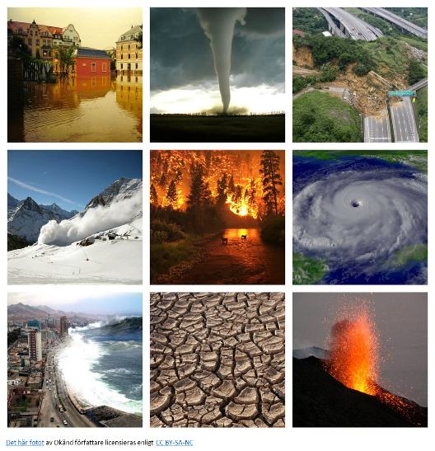
Floods and fires
Disaster 1
Match these key words from the report with their meaning.
1. canals a. dishonest activities, eg stealing from public money
2. corruption b. dying in the water
3. devastating c. loud sounds which warn people of danger
4. drowning d. people who steal
5. sirens e. something like streets, but filled with water for boats to travel on
6. offshore barriers f. something like walls or fences located in the sea to protect the land from flooding
7. thieves g. the daily movement of the sea towards and away from the land which is caused by the moon
8. tide h. very serious and destructive
Watch the report again and add the missing words from Exercise 1.

Streets and _________________1 merged as the second highest ________________ 2 ever recorded swept
through Venice on Tuesday. Undaunted, most tourists took to touring the city on gangplanks but some
chose to swim through Saint Mark's Square, the city's main Piazza. As waters hit 1.87 meters high, the
highest in half a century,____________________ 3 sounded. For residents, the effects are ________________4 :
"Our masks, our plates, everything. Look at what we're living with here. I just want to cry."

The city's mayor has declared a state of emergency, blaming the rising waters on climate change.
Meanwhile much-needed______________________ 5 designed to prevent floods remain unfinished. The project, started in 2003, has been dogged by delays, soaring costs and __________________6 scandals and
Venetians are demanding progress.

"It's been 10 years but they have done nothing. It's in total neglect, it does not work and they have
stolen six and a half billion dollars. Our politicians are all _____________________7 - they should be in jail."
The damage is estimated at hundreds of millions of dollars and there are concerns that this flood is the
starkest warning yet that the city is _____________________________8 .
Disaster 2
Underline the words that are almost the same in French. Then translate the words you don’t understand.
alerts blazing catastrophic spread flames smouldering complacent evacuate Watch the report again and add the missing words from Exercise 2.
Australia's fire service chiefs have described conditions as _______________________ 1 . High temperatures,
strong winds and dry conditions are making bushfires travel fast, and people are being warned to
prepare themselves or ________________________2 . "Complacency kills. We cannot afford for people to be
_____________________________3 . The fact that the catastrophic rating is there ... that's ... that's the highest level risk
available."

Dozens of fires are _____________________ 4 in the state of New South Wales and there are more in Queensland to the north and in Western Australia. And many have come close to cities, this one just 18 kilometers northwest of Sydney's famous Harbour Bridge, but firefighters were able to contain it.

"I got home from work and then heard sirens and came out the front and three or four fire trucks on
the street, ______________________5 as high as the trees, and everyone was running around like mad."

Another fire took hold in Sydney's western suburbs. These firefighters are hosing down the last of the
____________________________6 trees here but authorities are saying that this is the exception rather than the rule. In
these catastrophic conditions they can't hope to get on top of every fire.

Emergency __________________7 have been issued, some by phone, and some people warned it was too
late to leave their homes and they were safer inside, although that doesn't mean it's safe.

Many fires are out of control and with more strong winds and high temperatures forecast for the end
of this week they're likely to __________________________8 .

Talking point
Choose a disaster and find some facts about it then you tell your group about it, try to include these points:
• how the city/countryside has been affected
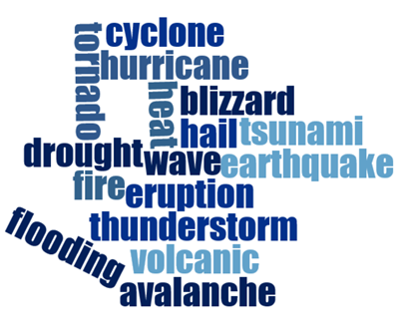
• how people have been affected
• the cost of rebuilding
• the cause of the disaster
• how this type of disaster could be prevented in the future

