Current Affairs – Media - Vocabulary

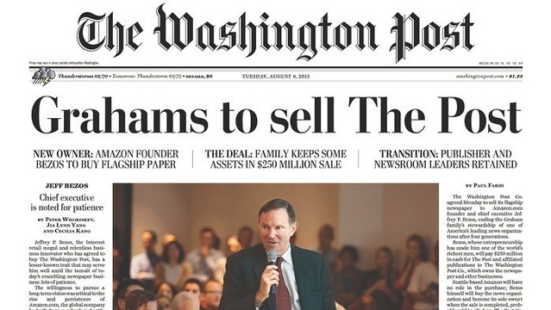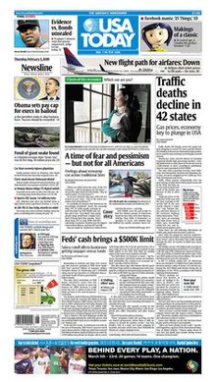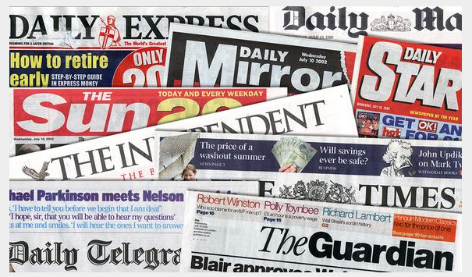

Current Affairs – Media – Vocabulary

Types of Newspapers
- tabloids = gossip newspapers

- broadsheets = newspapers printed on large sheets which are usually considered more serious

- daily / weekly / monthly newspapers = papers printed once a day / once a week / once a month

- quarterly newspapers = newspapers printed once every 3 months

- heavy newspaper = a newspaper with serious content

- gutter press = newspapers which focus on sensational journalism, often about the lives of famous people

- periodical = a newspaper or magazine published at regular intervals

- local / regional newspaper = a newspaper which contain news from a particular area
- national newspaper = a newspaper which contain news from the whole country

Current Affairs – Media – Vocabulary

Vocabulary Related to Newspaper Content

- headlines = heading or title appearing at the top of a page or article
- columns = news that is printed in vertical columns rather than taking a whole page
- obituaries = a section in the newspaper about people who have recently died
- horoscope = a section in the newspaper about star signs and zodiac signs which foretell the future
- weather report = a section in the newspaper for weather forecasts
- business section = a section in the newspaper with business news
- international / world news section = a section in the newspaper which focuses on news from abroad
- caption = a explanation or title matching a picture or cartoon
- letter to the editor = a section in the newspaper for people to express their views to the editor of the newspaper
- special feature = a special story
- editorial = a news article containing the editor’s opinions
- comic strip = a cartoon series in the newspaper
- advice column = a column in the newspaper where advice is given to people who write in for it
- TV guide = a section in the newspaper with a guide for TV programs for the coming day or week

Current Affairs – Media – Vocabulary

Useful Vocabulary Related to Newspapers

- circulation = the number of copies a newspaper distributes on an average day (some newspapers have a wider circulation than others)
- edition = a particular version of a text
- layout = the way articles are designed on a page (this can include the position of pictures, the number of columns and the size of headlines)
- attention-grabbing = a news story which draws public attention
- eye-catching = a picture or layout which catches a person’s eye
- in-depth = with many details
- sensational news = news which causes public excitement or interest
- black and white = without colour
- direct quotation = words taken directly from what a person has said
- paparazzi = a freelance photographer who follows celebrities
- front page = the first page of a newspaper
- supplementary magazine = a magazine which sometimes is given free with a newspaper
- back issue = an old newspaper edition
- subject matter = the topic dealt with in an article
- proof reader = a person who checks a text for errors
- fact checkers = a person (people) who checks if the newspaper facts and information in an article are correct
- hot off the press = news that has just been printed and is very recent
- readership = the collective readers of a newspaper (some newspapers have a large readership)
- issue (n) = 1. an important topic for a debate 2. a copy of a newspaper

